**RIASSUNTO COMPUTER VISION**

Sommario

1. INTRO 2

2. BASICS 2

3. LOW LEVEL IMAGE PROCESSING 6

4. CONVOLUTION FILTERING 10

5. MID-LEVEL – THRESHOLDING 12

6. EDGE DETECTION 13

7. IMAGE FEATURE DESCRIPTION 18

8. ML4CV – 8a 27

9. ML4CV – 8b 32

10. LOSS FUNCTIONS 36

11. NEURAL NETWORKS 43

12. CONVOLUTIONAL NEURAL NETWORKS 53

13. AUTOENCODERS - GANs 59

14. DIFFUSION MODELS 62

15. SEMANTIC SEGMENTATION 65

16. FUZZY MODELS 68

17. EXPLAINABILITY 69

1. **INTRO**

A digital image is a discrete representation of an analogic image as a finite set of numeric digital values, called picture elements or pixels. A digital image is a matrix with a finite number of rows and columns. A pixel is represented by one element in the matrix. The value of each pixel represents a channel that signifies a visual aspect of the image such as brightness, grayscale, color, and so on.

Image processing can be divided into three levels:

* Low-level processing: Noise reduction, contrast enhancement, reconstruction
* Mid-level processing: Edge detection, segmentation
* High-level processing: Object recognition, scene annotation, understanding

High level tasks are **Computer Vision tasks** that involve semantic. The **semantic gap** is a challenge because for a computer it’s difficult to associate an image (a matrix) with its meaning and a small change in the image can result in a very different matrix for the computer. The semantic gap contributes to the challenge of factuality, especially when systems like LLMs generate outputs based on incorrect or misunderstood image content, known as hallucinations.

1. **BASICS**

The human visual system is our biggest sensory system. Nearly half of the neurons in the brain’s **cortex** are dedicated to vision. Humans naturally approach vision problems by **breaking them down into smaller sub-problems** and using **multiple levels of representation** such as V1 (primary visual cortex), V2 (secondary visual cortex) and beyond. This **hierarchical** processing strategy was confirmed by Hubel and Wiesel in 1959 (awarded the Nobel Prize in 1981). One foundational concept in vision science is the **receptive field**, which refers to the specific region in the retina that a **sensory neuron** monitors. When something changes in that particular area—like light hitting a certain spot—the neuron becomes active.

The electromagnetic spectrum encompasses all forms of electromagnetic radiation. Human eye can only perceive a narrow band of this spectrum: the **visible light spectrum**, which spans wavelengths from approximately **400 to 750 nanometers** (nm). Each bundle of energy is called **photon**.

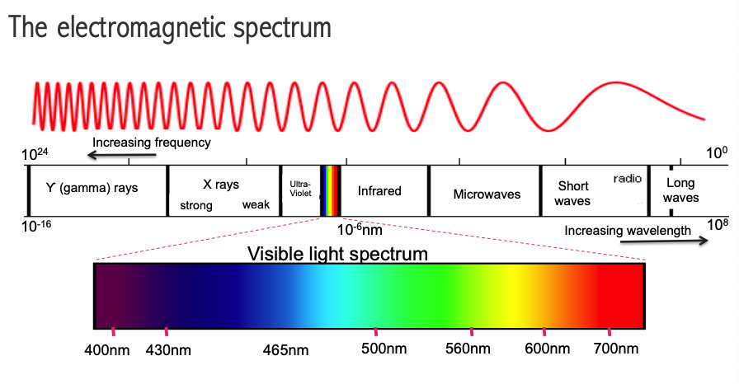

**Color** is the **visual perception** generated by signals that **retinal** **photoreceptors** send to the brain when they absorb electromagnetic radiation of wavelengths into visible light.

What makes one **color** different from any other is the **amount of energy**: violet light has the highest energy, red light has the lowest energy.

Objects have different colors because they absorb light with some energies and not others; objects that absorb all the colors are totally black, ones that reflect all the light are totally white. A green plant is green because it reflects green light (which reaches your eye) but absorbs blue and red.

The photoreceptive cells in the retina — **rods and cones** — play distinct roles:

* **Rods** (about 120 million per retina) are sensitive to light intensity and are crucial for night vision
* **Cones** (around 6 million) are responsible for color vision and are densely packed in the **fovea**, the small central area of the retina responsible for high-resolution vision and tasks like reading.

Rods are more than cones because they are smaller and it’s more difficult to operate in low light conditions for humans.

There are three types of cones, each tuned to a different range of wavelengths:

* S-Cones (Short wavelength): peak around 445 nm (blue light)
* M-Cones (Medium wavelength): peak around 535 nm (green light)
* L-Cones (Long wavelength): peak around 575 nm (red light)

This forms the basis of the Tri-stimulus theory (or trichromatic theory of color perception), which explains that all perceived colors are the result of different combinations of stimulation from these three types of cones. This biological reality matches the **RGB** color model used in digital imaging, where red, green, and blue are the primary channels.

The **CIE XYZ color space** was developed to represent all perceivable colors using three imaginary primary components:

* X, which captures a weighted mix of all visible wavelengths, with a focus on **red-green** sensitivity
* Y, which represents **luminance** (brightness)
* Z, which focuses on the eye’s sensitivity to **blue**, or short wavelengths

From this model, the **CIE xyY** **space** was derived. This space separates **chrominance** (x, y) — the color information — from **luminance** (Y).

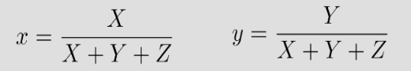

Any color in this space is represented by its brightness (Y) and its position (x, y) within a two-dimensional chromaticity diagram. In the CIE xyY chromaticity diagram, the edge of the horseshoe-shaped area defines **pure**. All other colors can be formed by mixing these pure colors. The center (barycenter of the triangle formed by primaries) represents **white**. The polygon inside, formed by connecting specific primary colors, is called the **gamut**, which shows the range of colors a system (like a display) can reproduce.

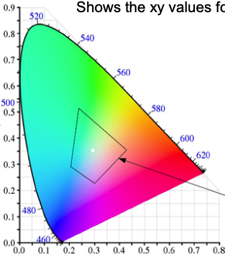

All visible colors can be produced by **combining three primary colors**, and this can be done in two ways:

* **Additive synthesis** (used in screens): for example red + green = yellow. Additive synthesis occurs in different ways:
  + **Spatial average**: colors placed very close together blend when viewed from a distance (like in pointillism or pixel-based displays).
  + **Temporal average**: rapidly alternating colors fuse into a single color in our perception.

This principle is used in CRT, LCD, and OLED displays. In screens, pixels are made up of very small subpixels (RGB), whose light is mixed to create various colors.

* **Subtractive synthesis** (used in printing): works by **removing wavelengths** from white light using filters or inks. Primary colors here are **cyan, magenta,** and **yellow** (CMY):
  + Cyan absorbs red and reflects green and blue
  + Magenta absorbs green and reflects red and blue
  + Yellow absorbs blue and reflects red and green

By layering these filters, you subtract different parts of the spectrum to create the desired color. When all three are combined, nearly no light passes through, resulting in a very dark color called **bistro**. This principle is used in inkjet printers.

An analog image is a continuous function, while a digital image is a matrix of discrete values (pixels). To convert an analog image to digital, two main steps are required:

* **Sampling**: Dividing the image into a grid of pixels. The sampling rate (how close the pixels are) affects how much detail the image retains:
  + Size: Total number of pixels (e.g., 640×480).
  + Resolution: Pixel density, typically in PPI (pixels per inch) or DPI (dots per inch). Higher resolution means better detail, but larger file sizes.

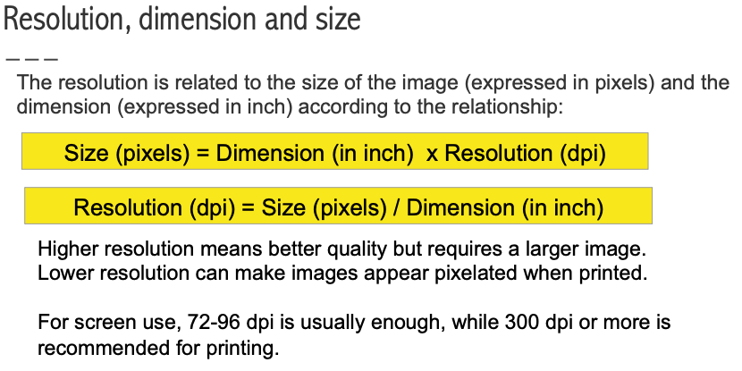

* **Quantization**: converts continuous intensity values into discrete digital levels. The **bit depth** determines how many different intensity levels can be represented. Usually we use 1 byte (8 bit) for each of the red, green and blue component, so 24 bits for each color (2^24 different colors).

A gray-level image is a digital matrix where each pixel stores a brightness value from 0 (black) to L-1 (white). For example, with 8-bit encoding (2⁸ = 256 levels), values range from 0 to 255.

**Size = N × M × m bits (where m is the number of bits per pixel).**

The dynamic range of an image refers to the number of different gray levels it uses:

* High dynamic range → rich contrast, many gray levels
* Low dynamic range → flat contrast, few gray levels

A digital color image is made of 3 matrices, one for each RGB channel. Each matrix stores intensity values using a certain number of bits (e.g., 8 bits per channel = 24 bits per pixel).

**Total size = 3 × M × N × m bits**

A color model is a mathematical way to represent colors using numerical values. Most digital models use three dimensions — one for each primary color component.

Common models are:

* RGB (Red, Green, Blue) — additive model used in screens
* CMY (Cyan, Magenta, Yellow) — subtractive model used in printing
* **HSV:**
  + **Hue: the base color (e.g., red, green, blue…)**
  + **Saturation: how intense or pure the color is (from gray to vivid)**
  + **Value: brightness level (from black to full brightness)**
* L*a*b*:
  + L (Lightness): 0 = black, 100 = white
  + Green to Red axis (negative = green, positive = red)
  + b: Blue to Yellow axis (negative = blue, positive = yellow)

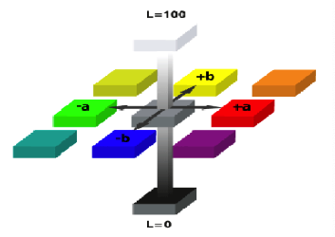

To convert RGB to grayscale, we reduce three color values to a single brightness value (luminance). A simple but less perceptually accurate formula is:

**L = (R+G+B)/3**

With this formula we obtain a conversion that doesn't match our perceptions of the given colors. A more realistic method:

**L=0.299*R+0.587*G+0.114*B**

1. **LOW LEVEL IMAGE PROCESSING**

To improve image quality, we apply low-level operators, which are either:

* **Point operators**: modify each pixel independently (e.g. brightness, contrast)
* **Neighborhood operators**: modify a pixel using information from surrounding pixels (e.g. blurring, sharpening, edge detection)

Image quality is primarily described by:

* **Brightness**: overall intensity
* **Contrast**: variation of intensities

Contrast refers to how much adjacent pixels differ in intensity or color.

* High contrast → big differences (clear edges, good detail)
* Low contrast → small differences (washed-out appearance)

It’s influenced by the image’s **dynamic range** (number of gray levels used). There are many definitions of image contrast:

* **Michelson contrast** (visibility): CM ranges from 0 (no contrast) to 1 (maximum contrast). Imax and Imin represent the highest and lowest intensity in the image. Imax-Imin=dynamic range.

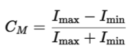

* **Root Mean Square (RMS) Contrast** (for complex images):

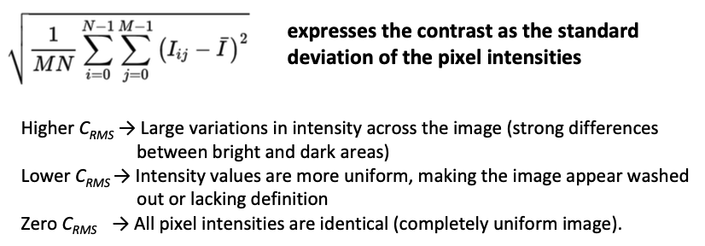

An image’s contrast is related to how spread out the pixel intensity values are.

* Low contrast → pixel values concentrated in a narrow range
* High contrast → values spread over a wide range

**Goal of contrast enhancement**: stretch these values (e.g., to the full range [0, 255]).

Histogram **equalization** enhances contrast by making the intensity histogram more uniform (flat). The method redistributes pixel values so they are more evenly spread across the available brightness range. This is done by mapping one distribution (the original histogram) to another distribution (a more uniform distribution of values). To accomplish the equalization we use the **Cumulative Distribution Function (CDF)** as a transformation function.

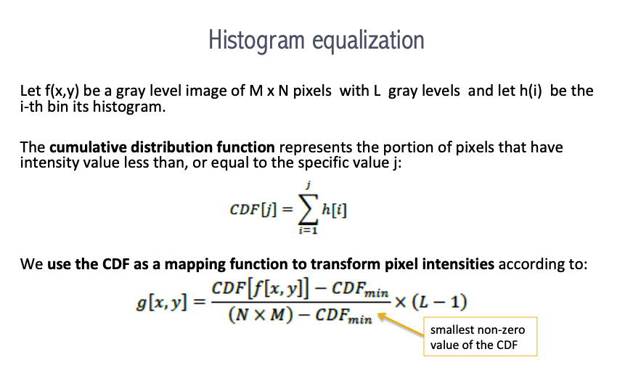

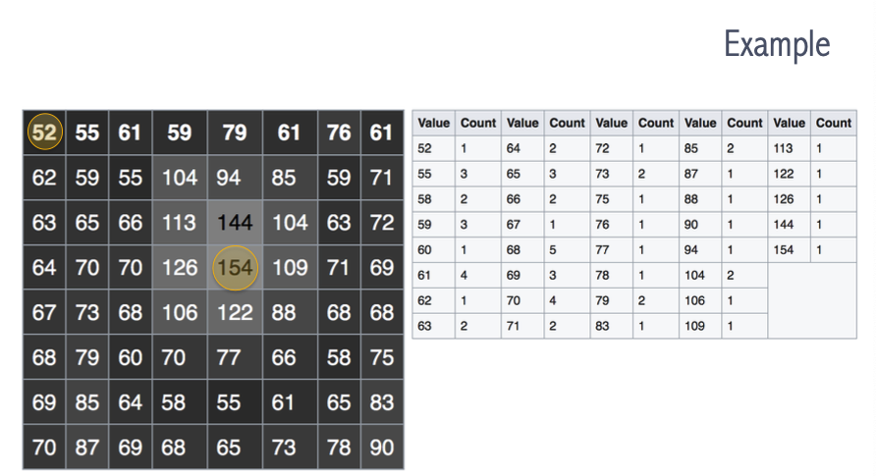

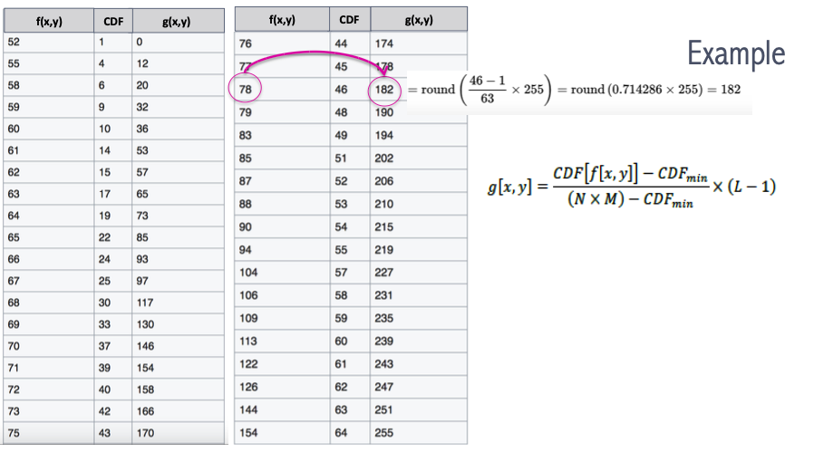

In **block histogram equalization**, instead of equalizing the whole image globally, the image is divided into small blocks (e.g., M×M), and histogram equalization is applied separately in each. This can cause **blocking artifacts** (the resulting image may shows intensity discontinuities at block boundaries).

One way to eliminate blocking artifacts is to compute non-overlapped block-based equalization functions and then smoothly interpolate the transfer functions as we move between blocks. We use a moving window and recompute the histogram for every MxM block centered at each pixel This technique is known as **Contrast-Limited Adaptive Histogram Equalization (CLAHE).**

In image processing, a **gray level transformation** applies a function f(x) to each pixel to change its intensity. This function, called a **transfer function**, can be either linear or nonlinear.

The simplest way to change brightness is to add a constant c to every pixel:

**f(x) = x + c**

If c > 0, the image gets brighter.

If c < 0, the image gets darker.

To make sure pixel values remain within the valid range, we clip the values:

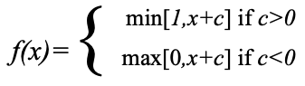

Another basic linear operation is the **negative transformation**: f(x) = 255 – x

This inverts the image: dark areas become light and viceversa. It’s useful in medical imaging to highlight details that are not easily visible in the original image.

**Linear contrast stretching** improves the visibility of details by expanding the range of gray levels in the image. If the original pixel values lie within a narrow range [a, b], we linearly map them to the full range [0, 255]:

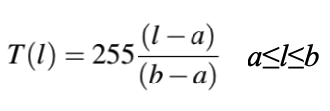

Linear stretching increases dynamic range but keeps the general structure of the histogram.

Histogram equalization redistributes intensity values across the entire range, often improving contrast but possibly introducing artifacts or unnatural effects.

Instead of using just a single linear function, we can adopt more flexible approaches like **piece-wise linear stretching**. This technique allows us to define multiple linear segments that adjust different intensity ranges independently, enhancing specific areas of the image more effectively.

A very common transformation is the **power-law or gamma correction**, which follows the formula:

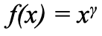

Depending on the value of gamma, we can either brighten or darken the image. If gamma is less than 1, dark regions become brighter. If gamma is greater than 1, the image becomes darker overall. There are also many other approaches. These include nonlinear functions such as logarithmic and sigmoid transformations, each with its own characteristics, often chosen based on the specific needs of the image or application. When we need to speed up the enhancement process, especially when applying the same transformation to many pixels, we can use a **look-up table (LUT)**. This table stores precomputed mappings from original pixel values to their transformed values. Instead of recalculating each time, the system just replaces each pixel with its corresponding value from the LUT, saving time and resources.

1. **CONVOLUTION FILTERING**

Unlike point operators, which modify each pixel independently, **neighborhood operators** **(local operators)** compute the output pixel value by considering the values of the surrounding pixels. This is the foundation of many image enhancement techniques such as edge detection, blurring, sharpening, and noise reduction.

A key tool in this context is the **filter**. Filters are local operators used to select or remove certain frequency components from an image. **Frequency** refers to **how quickly pixel intensity values change across space**. Low frequencies correspond to slow variations (like in the sky or skin), while high frequencies represent rapid changes (like edges or noise).

A **low-pass filter** removes high frequencies, resulting in a smoothing or blurring effect. Conversely, a **high-pass filter** removes low frequencies, enhancing edges and fine details. In the frequency domain, an image is represented by its frequency components instead of its spatial pixel layout. This is achieved using the Discrete Fourier Transform (DFT), which decomposes the image into sinusoidal components of different frequencies. To apply filters in the spatial domain, we use structures called filters, **kernels**, or **masks**. A kernel is a **small matrix** that is slid over the image, and for each position, a new pixel value is calculated by combining the neighboring pixel values with the kernel’s weights. This operation is known as **convolution**. The resulting processed image is called the **feature map**, **activation map**, or **convolved feature**.

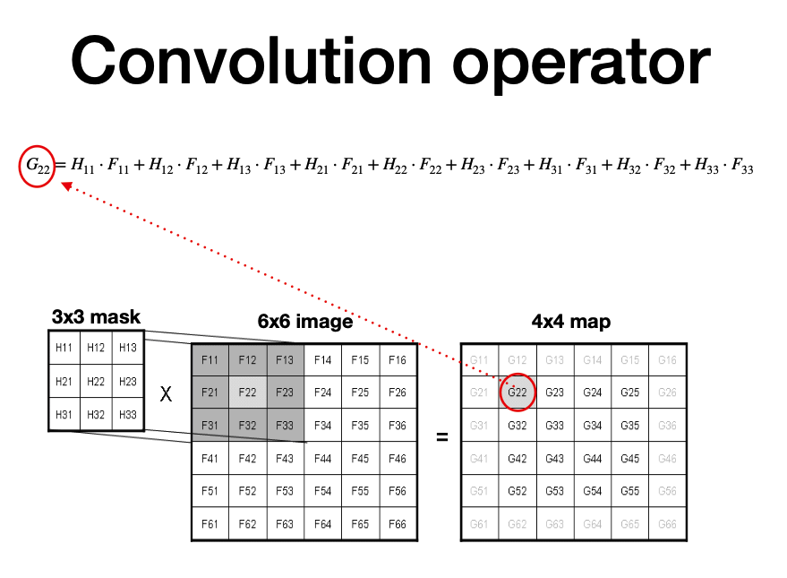

The **stride** is the number of pixels by which we slide the filter over the image. If the stride is 1, we move the filter one pixel at a time, scanning the image in small steps. If the stride is 2, we move the filter two pixels at a time, and so on. Increasing the stride produces a smaller output image, because fewer positions are visited by the filter. The size of the output image can be calculated using the formula (**N - F) / stride + 1**, where N is the size of the input image and F is the size of the filter. However, depending on the stride and filter size, the result might not always be an integer, and the output might not cover the input image properly. In these cases, or when we simply want the output to have the same size as the input, we apply **padding**.

Padding consists of **adding extra pixels around the border of the image**, typically filled with zeros. This allows the filter to be applied even to pixels at the edges of the image. Padding serves two main purposes: it helps maintain the original dimensions of the image after convolution (which is called “**padding same**”), and it ensures that the stride fits correctly with the input size, avoiding partial overlaps or misalignment. If we do not use padding, the convolution is called **narrow convolution**, and the output image will be smaller than the input.

**Smoothing** or **blurring** is a technique used to soften abrupt transitions between pixel intensities in an image, typically to remove irrelevant small details or noise. To achieve this effect, we apply low-pass filters, which allow low frequencies to pass while attenuating higher frequencies. In practice, the larger the filter size, the stronger the smoothing effect will be. Smoothing is widely used for noise removal purposes. There are different types of noise: salt-and-pepper noise, where random black and white pixels appear; impulse noise, which consists of random white pixels; and Gaussian noise, where intensity variations follow a normal distribution. Each type of noise requires different strategies for removal.

One basic smoothing method is **average blurring**, also called **mean filtering** or **box filtering**. In this technique, the image is convolved with a kernel of ones, usually a small window like 3×3, and the result is divided by the number of elements to compute the mean value. Each output pixel is replaced by the average of its neighborhood, leading to a smoothing effect but also a tendency to create new gray levels.

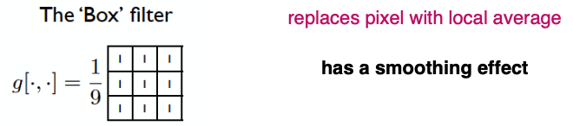

Another very common tool is the **median filter**. Instead of averaging, the median filter selects the median value within a pixel’s neighborhood, place ita t the centre of the block and continue for all pixels. This process is non-linear and is particularly good at removing isolated noise spikes, such as those caused by **salt-and-pepper noise**. Since no convolution is involved and values must be ordered to find the median, this method is computationally more expensive.

The **Gaussian smoothing operator** is a 2D convolution that applies a filter shaped like a Gaussian function. This filter reduces image components with frequencies lower than a certain threshold and the amount of smoothing depends on the standard deviation parameter σ. Essentially, a Gaussian filter helps in blurring the image while maintaining a more natural, gradual transition compared to simple mean filtering. The parameter σ is the key factor controlling the smoothing: a small σ results in slight blurring, while a large σ produces strong blurring. The size of the kernel is directly related to σ. In practice, once we set the variance (σ²), the corresponding kernel size is automatically determined.

**High-pass filters** are used to do the opposite: rather than smoothing the image, they **sharpen** it. A high-pass filter boosts the intensity differences between neighboring pixels, enhancing edges and details. As a result, the image appears sharper because the contrast between adjacent areas increases.

1. **MID-LEVEL – THRESHOLDING**

After enhancing and filtering the image, the next step is **mid-level image processing**.

The goal at this stage is to extract useful information from the image, such as **features**, **measurements**, or regions of interest (**ROI**). To do this, several tasks can be performed, like separating objects from the background, detecting shapes, or performing segmentation.

**Image segmentation** is the process of taking an image and grouping its pixels into meaningful segments, i.e., regions that share certain characteristics like color, intensity, or texture.

There are two main types of segmentation approaches:

* **Similarity-based** methods, which group together pixels that are similar according to some criterion (for example: thresholding, region-growing, clustering).
* **Discontinuity-based** methods, which instead look for abrupt changes in pixel values, such as in edge detection.

A very simple and fast similarity-based technique is **thresholding**. Thresholding is based on the idea that images are composed of regions with different intensity levels. It aims to partition the image into homogeneous regions by applying a **threshold**: pixels above the threshold belong to one class (for instance, the foreground), while pixels below belong to another (like the background). Thresholding is a **point operator**, meaning it does not consider the spatial relationships between pixels, only their intensity.

When applying a binary threshold, the result is a binary image, where the pixels are either fully black (0) or fully white (max value). However, there are different types of global thresholding available. The crucial step is to **select a proper threshold** value that maximizes the separation between the different pixel classes. A good practice is to place the threshold at the deep valley of the image histogram, where there is a natural separation between pixel intensity distributions. But if the valley is not clearly defined, finding a global threshold becomes much more difficult.

The **Otsu method** is one of the most popular techniques for automatic threshold selection in image processing. For each possible threshold value, the method computes the spread (variance) of pixel levels within each class. The optimal threshold is the one that **minimizes the within-class variance** (pixels inside each class are similar) or equivalently **maximizes the between-class variance** (the two classes are well separated).

When segmenting an image into more than two regions with different grey levels, multiple thresholds are used, a process called **multi-thresholding**. This technique can be visualized on the histogram by multiple dividing lines, separating the pixel intensities into multiple classes. In images where the background is not uniform, global thresholding may not work well. Instead, we use **local (adaptive) thresholding**:

* The image is divided into sub-images (small regions).
* Each region computes its own threshold independently.
* Thresholded regions are then merged to form the final image.

Local thresholding is more computationally expensive but works better when there is high variability across the image.

1. **EDGE DETECTION**

The main goal of discontinuity-based segmentation is edge detection, essential for identifying meaningful structures in the image. An edge is characterized by a sudden change in pixel intensity. It represents a boundary where the properties of an image, like depth or surface color, change drastically. Mathematically, an edge pixel has a gray level that differs significantly from its adjacent pixels. Images can be considered as functions, where edges correspond to rapid changes in this function.

To find these changes, we use the concept of **derivatives**. In the context of images, derivatives help identify where rapid intensity changes occur, i.e., where edges are. Thus, detecting edges in an image involves calculating **partial derivatives** at each pixel location and identifying regions with high derivative values. In digital images, derivatives are approximated using discrete differences:

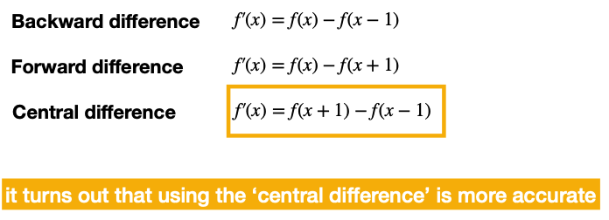

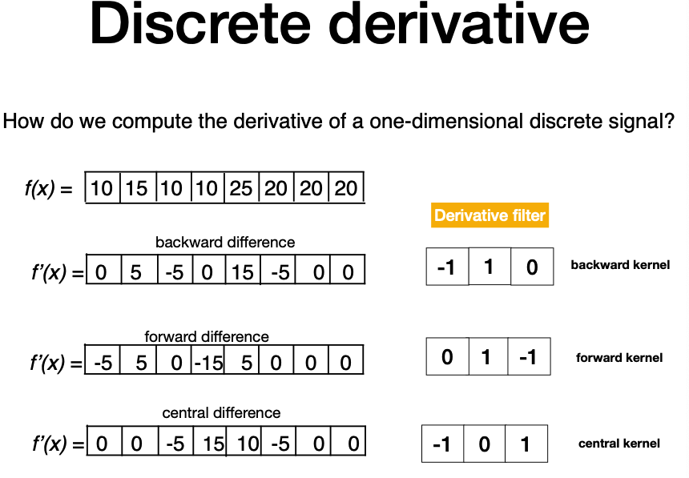

In single-variable functions f(x), derivatives measure the rate of change. However, images are multi-variable functions, typically f(x, y), requiring a more general concept: the **gradient**.

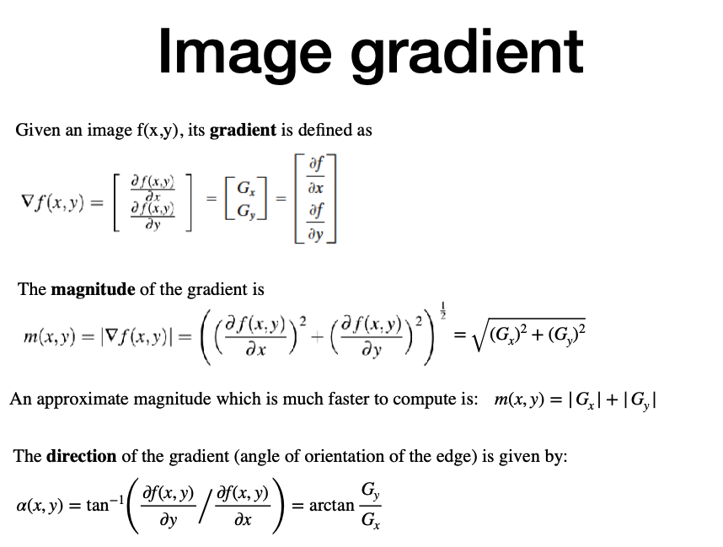

**Gradient vectors** point toward the direction of the most rapid increase in intensity.

**Vertical edges**: Rapid change occurs in the x-direction.

**Horizontal edges**: Rapid change occurs in the y-direction.

To compute the gradient in images, we convolve the image with a 3×3 kernel (also called a mask or filter). **Prewitt** kernels are commonly used (Prewitt Operator uses simpler kernels that do not include smoothing):

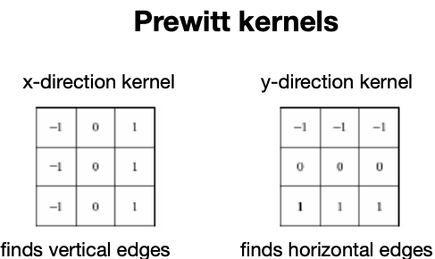

When an image contains a lot of noise, the calculation of partial derivatives becomes ineffective for identifying edges. Noise introduces random fluctuations that can mask the true structure of the image, making it difficult to detect where real edges are located.

To address this problem, it is important to **smooth the image before computing its gradient**. Smoothing reduces the high-frequency noise, while preserving the significant changes in intensity that correspond to edges. Typically, this is achieved by applying a Gaussian filter to the image. To effectively detect edges, especially in noisy images, specific gradient operators are used. One of the most common is the **Sobel operator**.

The Sobel operator uses two different kernels:

* One for detecting changes along the x-axis (horizontal changes).
* Another for detecting changes along the y-axis (vertical changes).

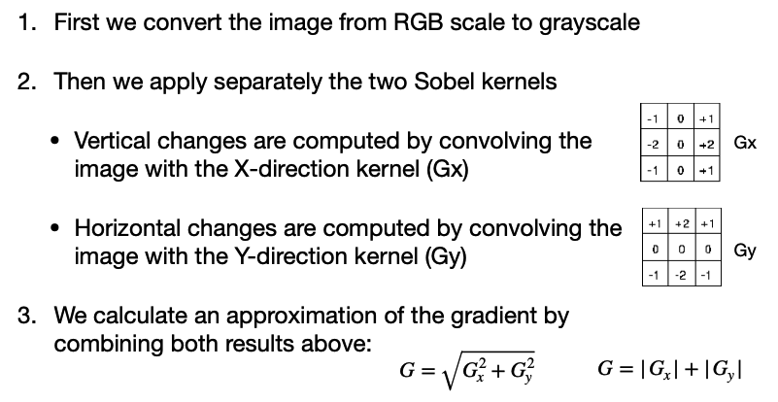

The general procedure to detect edges in an image is as follows:

* Compute the gradient image, by calculating the partial derivatives at every pixel location.
* Analyze the gradient values in the neighborhood of each pixel. If the gradient at a pixel exceeds a certain threshold value, that pixel is classified as part of an edge. This process produces an edge map containing the candidate edge points.
* Link the edge points together into continuous contours, using an edge-linking process.

It is important to note that the results of edge detection are very sensitive to the choice of the threshold value. Problems can arise when an edge is represented by a soft transition instead of an abrupt change in intensity.

Applying edge detection algorithms directly to **high-resolution images** can lead to the detection of too many irrelevant edges, cluttering the result. To mitigate this, smoothing kernels are often used to reduce high-frequency content before applying edge detection. In particular, a blurring filter is applied to the image first.

However, it is crucial to find the right balance:

* If we blur too little, noise remains and unnecessary edges appear.
* If we blur too much, important edges may be lost.

The **Canny Edge Detection** algorithm is a very famous method used for identifying edges in images. It follows a multi-step process:

1. **Smoothing** the Image: to achieve smoothing, a Gaussian filter is applied to the image.
2. Calculating the **Gradient Magnitude:** This involves finding the intensity gradients of the image. Typically, Sobel filters are used to approximate the derivatives in both the horizontal (x) and vertical (y) directions. The result of this step is the gradient magnitude image, which highlights the regions of the image where intensity changes are the most significant — these regions are potential edges.
3. **Non-Maximum Suppression:** At this point, the gradient magnitude image may have wide and blurred edges. To sharpen the edges and achieve thin, precise contours, non-maximum suppression is applied. This technique involves checking the gradient magnitude of neighboring pixels along the gradient direction and suppressing any pixel that is not a local maximum. In this way, only the sharpest edges are preserved.
4. **Thresholding** into Strong, Weak, and No Edge: Even after non-maximum suppression, there can still be some noise and weak edges in the image. To differentiate between strong and weak edges, a process called **hysteresis thresholding** is performed. Two thresholds are defined: a **high threshold (T)** and a **low threshold (t)**. Pixels with gradient magnitudes greater than T are considered **strong edges**, pixels with gradient magnitudes between t and T are considered **weak edges**, and pixels with magnitudes below t are discarded as **non-edges**.
5. Connecting Edges: In the final step, strong edges are immediately classified as edges. Weak edges, however, are classified as edges only if they are connected to strong edges — typically by examining the eight neighboring pixels. This linking ensures that only relevant weak edges, those that are part of meaningful contours, are retained, and isolated noise points are discarded.
6. **IMAGE FEATURE DESCRIPTION**

**Image features** are pieces of information within an image that are relevant for solving specific tasks. A feature could be something simple, like the value of a single pixel, or something more complex, such as edges, corners, or shapes. To better represent images, we use feature descriptors, which convert an image from its width x height x channels format into a feature vector of fixed length n.

The goal of image feature descriptors is to **capture similarities among images** by extracting meaningful features, effectively transforming pixel space into a more abstract feature space. Features provide an intermediate abstraction level, bridging the gap between raw pixel data and the semantic content of the image. Once images are represented through features, we can measure the similarity between them by comparing their descriptors, typically through feature matching techniques using distances like the Euclidean distance.

One basic approach to representing image features is simply using **pixel values**. This method collects the pixel intensity values from a local patch of the image, forming a vector. This technique works well when the geometry and appearance of the object remain unchanged and is closely related to what is known as **template matching**. Template matching is a brute-force method for detecting objects within images. It involves selecting a small patch, or template, and sliding it across the entire image to find the location where the template matches best. At each position, a correlation score is computed to evaluate how well the template matches the region. However, template matching may fail under several conditions: when objects appear at **different scales**, have **different orientations**, experience **lighting changes**, are viewed from different perspectives, undergo motion blur, or face partial occlusions. Additionally, it may fail when **mirrored versions** (like left vs. right hands) appear.

**Image classification** is the task of assigning a label (like “cat”, “dog”, “truck”, “plane”, etc.) to an input image. Humans easily recognize objects (like a cat) because we interpret the visual content at a high semantic level. However, for a computer, an image is just a grid of numbers representing pixel intensity values. Bridging this semantic gap between low-level pixel values and high-level understanding is one of the major challenges. When the **camera moves** or the viewpoint changes, all pixel values can change significantly. This variability makes classification harder because the same object may look very different under different viewpoints. To tackle variability, we must **extract meaningful features** from images. Features should capture essential information about the object, such as shape or texture, and allow us to recognize it even if the viewpoint changes. One simple way to describe an image is using a **color histogram**, which counts the number of pixels for each color or hue. This method is useful because it is **invariant to image scale and rotation**. However, a major limitation is that images with very different content but similar color distributions can end up having very similar histograms, leading to incorrect matching. Moreover, color histograms ignore the **spatial information** — they don’t tell us where the colors are located in the image.

To address this limitation, the concept of **Spatial Pyramid Representation** was introduced. Instead of representing an entire image with a single global descriptor, the image is divided into increasingly finer spatial regions — for example, first into four quadrants, then into sixteen smaller areas, and so on. For each sub-region, a descriptor (such as a histogram) is computed separately. By combining these local descriptors at multiple levels, the spatial information about where features appear in the image is partially preserved. This method significantly improves the performance of image recognition systems compared to using only global descriptors. However, even with more sophisticated descriptors, challenges remain. For instance, many different images may share the same dominant colors (such as sunsets, flowers, or fruit), which can confuse color-based systems. This is known as the problem of **same colors but different semantics**. On the other hand, the same object might appear very different in color under varying lighting conditions, resulting in **different colors but same semantics**.

The **Histogram of Oriented Gradients**, commonly referred to as **HOG**, is a feature descriptor that captures both global and local information from an image. It is widely used in object detection tasks, particularly human detection. HOG describes the structure of an image by capturing the distribution of intensity gradients or edge directions. The process starts by dividing the image into small, connected regions called **patches**, typically of size 8x8 pixels. Within each patch, the algorithm quantizes the gradient directions into 9 bins, creating a local histogram that represents the dominant orientations. For example, a 320x240 image would be divided into a grid of patches, resulting in 40x30 patches and, given 9 bins per patch, a feature vector containing 10,800 values. Each 8x8 patch first captures pixel values (192 values if RGB channels are used) and then computes gradient magnitudes and directions (128 values per patch if considering x and y gradient components). These gradients are then aggregated into the orientation histogram, weighted by the gradient magnitude. The advantage of HOG is that it operates locally on small cells, which makes it relatively **invariant to global geometric transformations** such as translation or scaling — although it remains sensitive to **object orientation**. However, despite its strengths, HOG has some limitations. One key challenge is **illumination variation**. Since gradients depend on intensity differences, changes in lighting conditions can significantly alter the gradients, leading to less reliable features. Another challenge is **deformation** — when the shape of an object changes affecting the descriptor’s consistency.

**Local features** are preferred because they can offer more robust image representations. For these features to be effective, they should maintain invariance to various transformations while keeping memory usage low. Over time, many local descriptors have been developed to meet these criteria. **Corners** are especially important because they are highly distinctive in most images and help in identifying and localizing objects. Corner points are those that remain consistent under transformations like translation, rotation, and changes in illumination. A corner can be defined as the **intersection of two edges**. One way to detect corners is by analyzing the gradient of an image: when **gradients change sharply in multiple directions**, it indicates the presence of a corner. A simple method is to look through a small window over the image; if moving this window in any direction results in significant intensity changes, a corner is likely present. Technically, to detect corners, gradients are computed over a small region — not just at a single pixel. Gradients in both x- and y-directions are calculated, forming gradient arrays. By analyzing the distribution of these gradients, it becomes possible to detect edges and corners. This method forms the basis for the Harris Corner Detector. The idea is that:

* In **flat** regions, gradients are small in all directions.
* Along **edges**, gradients are strong in one direction but weak in the other.
* At **corners**, gradients are strong in multiple directions.

The **Harris detector** works by examining changes in intensity caused by small shifts of a local window. If shifting the window leads to significant changes in pixel intensities, it likely indicates the presence of a corner. To quantify this, we define a function:

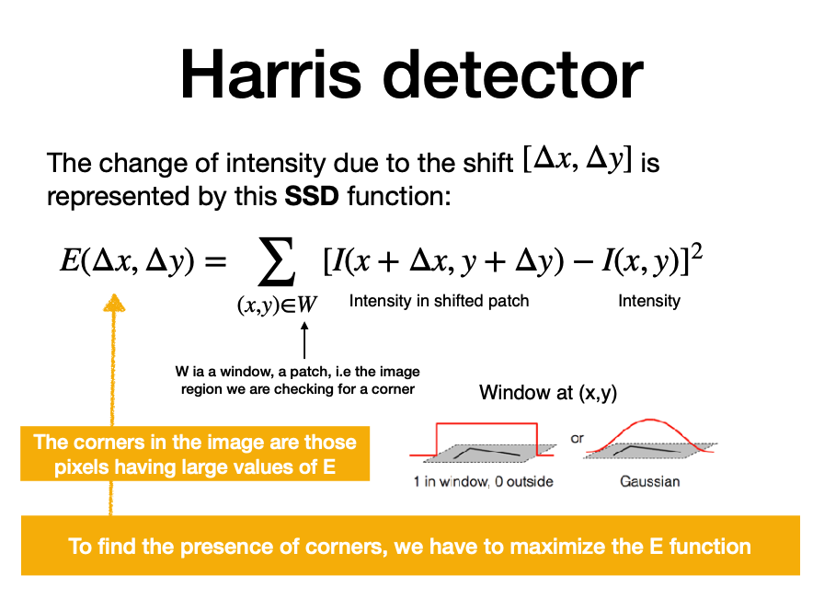

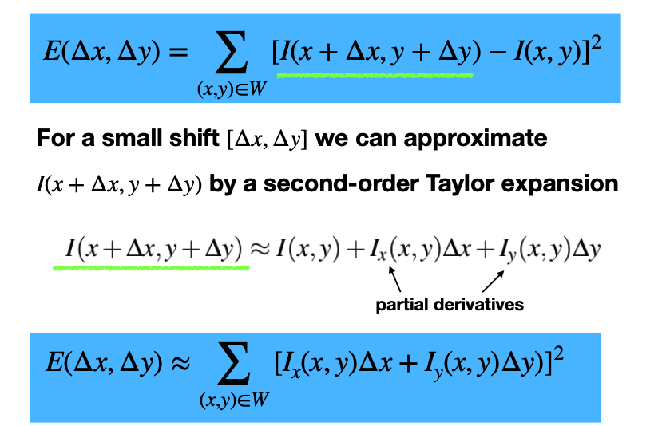

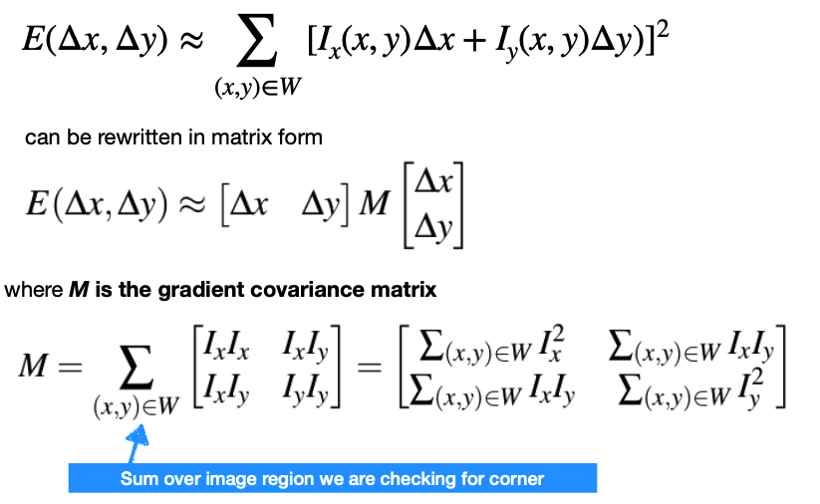

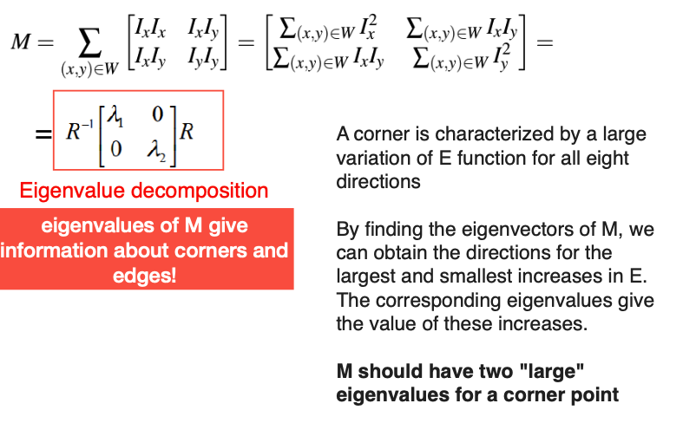

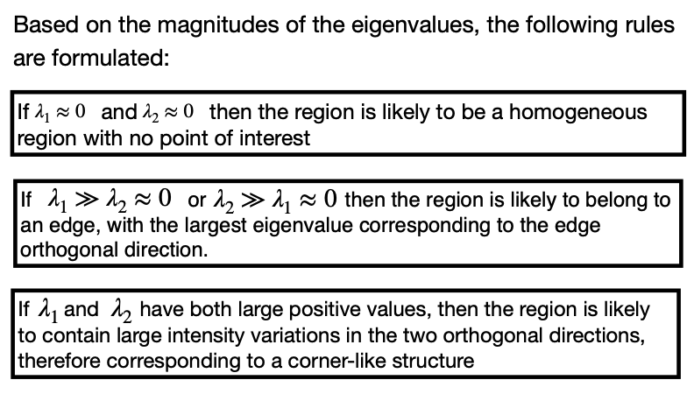

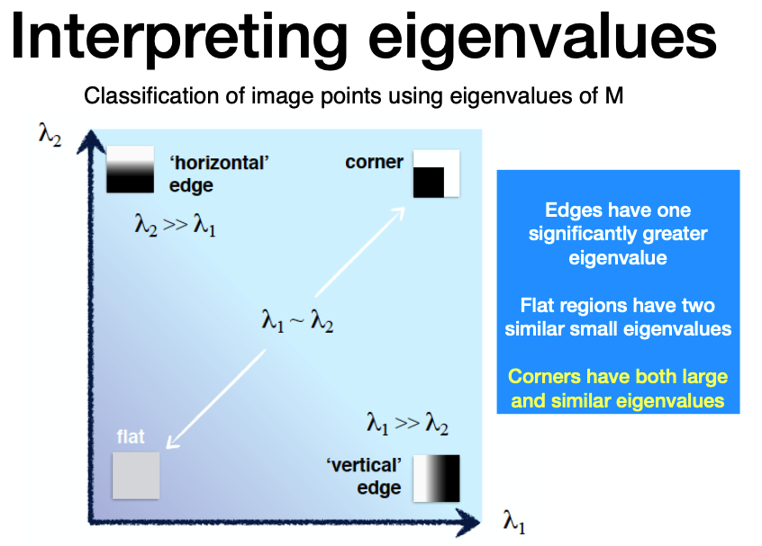

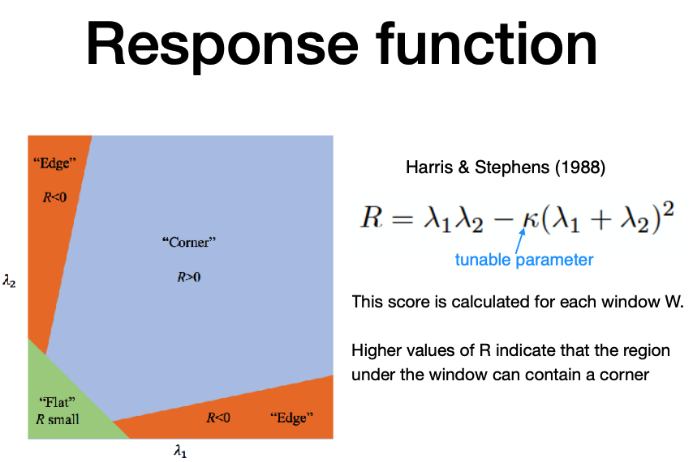

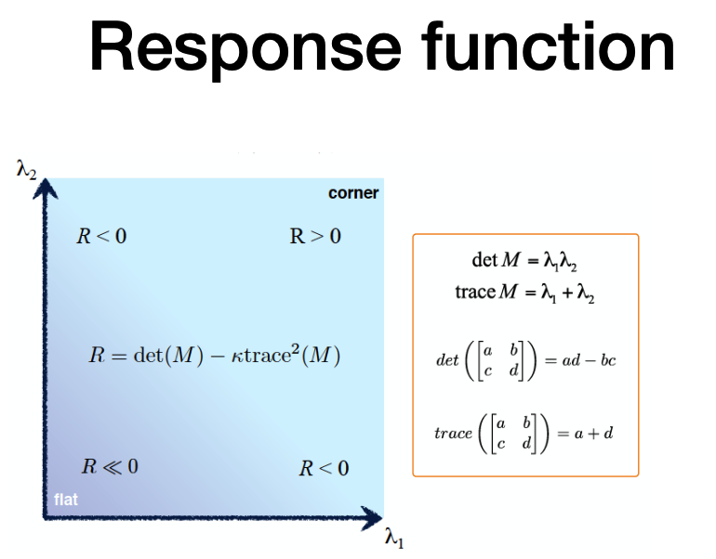

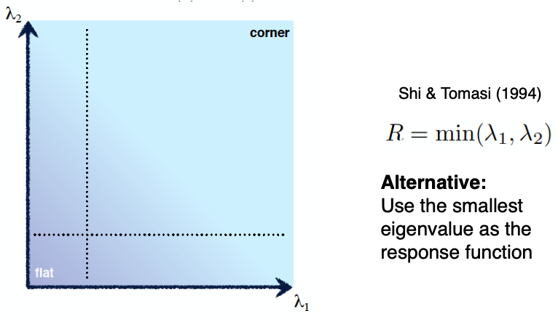

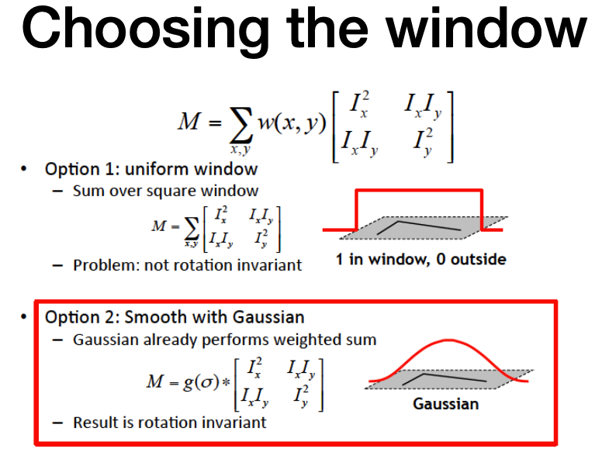

The Harris corner detector has an important property: it is **rotation invariant**. When the image rotates, the shape of the underlying intensity distribution changes orientation, but the eigenvalues—used to detect corners—remain the same. Therefore, the corner response R is unaffected by image rotation. However, the Harris detector is **not scale invariant**. Since it uses a fixed small window to analyze the local gradient structure, if the image is resized (scaled up or down), the detector may fail. The fixed-size window no longer captures the same gradients at different scales, making it unsuitable for detecting features across varying image resolutions.

In many real-world computer vision applications—such as object recognition, robotic mapping, gesture recognition, and video tracking—objects can appear at drastically different scales or orientations. This makes it essential to detect key points in an image that remain consistent despite these variations. These robust points are referred to as **scale-invariant features**. One of the foundational techniques to achieve this is **SIFT (Scale-Invariant Feature Transform)**, introduced by David Lowe in 1999. The goal of SIFT is to detect points of interest—**keypoints**—that are stable across changes in scale. A true keypoint is one that continues to appear even when the image is resized or blurred. SIFT follows some steps:

* **Building the Scale Space**: To detect features across different scales, SIFT constructs a scale space, which is essentially a pyramid of images at progressively lower resolutions. Each level in the pyramid is called an “octave”, and within each octave, the image is blurred multiple times using Gaussian filters with increasing standard deviation (σ). This allows for comparison of image structures across scales.
* **Difference of Gaussians (DoG)**: For each octave, SIFT computes the Difference of Gaussians (DoG), which is the subtraction of two blurred images with slightly different σ values. The DoG approximates the Laplacian of Gaussian, which helps identify regions of rapid intensity change—ideal candidates for keypoints.
* **Finding Keypoints:** To identify candidate keypoints, SIFT searches for local extrema (minima or maxima) in the DoG images. Each pixel is compared to its 26 neighbors in a 3×3 region—both at the current and adjacent scales. If it is the maximum or minimum among all neighbors, it is marked as a potential keypoint.
* **Keypoint Localization:** Not all detected extrema are stable or useful. SIFT filters out: Low contrast keypoints (which may be noise), Keypoints that lie along edges (which are poorly localized). This is done by computing the Laplacian at each candidate point to evaluate its contrast and curvature properties, similar to the Harris corner detector refinement process.
* **Orientation Assignment**: To make keypoints rotation invariant, SIFT computes the local gradient direction and magnitude around each keypoint. An orientation histogram with 36 bins (each covering 10 degrees) is built. The dominant direction (or directions) are assigned to the keypoint. This ensures that the descriptor later built around the point is aligned with its orientation, not the image’s.
* **Keypoint Descriptor:** The final step is to generate a descriptor for each keypoint. A 16×16 window is taken around the keypoint, aligned with its dominant orientation. This window is divided into 16 sub-blocks (4×4 grid). For each block, an 8-bin orientation histogram is computed. This results in a 128-dimensional vector (16 × 8), which is the SIFT descriptor. It captures the local structure of the image around the keypoint in a compact and robust way.

SIFT allows for robust object matching across images taken from different viewpoints, under different lighting, or at different resolutions. It is a powerful tool for matching objects in cluttered scenes or aligning images for tasks like panorama stitching, 3D reconstruction, and tracking.

The **Hough Transform** is a powerful technique used in computer vision to detect geometric shapes in images, especially lines, circles, and ellipses. The fundamental principle is that each edge point in an image “votes” for all possible lines (or other parametric curves) that pass through it. These votes are collected in a parameter space, and the points in this space that receive the most votes represent the most likely lines in the original image.

This makes it possible to detect lines even when the actual edge pixels are sparse or broken.

In the **image space** (denoted as x, y), we identify edge points using a method such as the Sobel operator. Each edge point (x, y) corresponds to all possible lines passing through it, defined by the line equation: **y = mx + b**. Rearranging, we get: **b = -mx + y**. This defines a line in the **parameter space** (m, b) . Thus, each point in the image becomes a line in the parameter space. One edge point in the image space maps to a line in the (m, b) space. Two edge points map to two lines in parameter space that intersect at a unique point. This point of intersection corresponds to the parameters of the line that passes through both edge points. Multiple points (e.g., 4 edge points) will generate multiple lines in parameter space, and their intersection indicates a best fitting line in the original image space. So, finding a consistent intersection in parameter space gives us the most probable line in the image. To detect lines using Hough Transform, we perform a voting procedure:

* Quantize the parameter space (m, b) into a finite grid of cells.
* Initialize an accumulator array A(m, b), setting all values to 0.
* For each edge point (x, y) in the image:
  + Loop over a range of slopes m, calculate corresponding intercepts b = -mx + y
  + For each (m, b), increment A(m, b) by 1.
* At the end, local maxima in A(m, b) indicate the most likely lines.

**Haar-like features** are patterns used to detect contrast differences between adjacent regions in an image. They are represented using simple rectangular structures. The basic Haar features include:

* Two-rectangle features (vertical/horizontal): detect edges.
* Three-rectangle features: detect lines.
* Four-rectangle features: detect diagonal lines or textures.

These features are applied using **Haar filters** (or kernels). The filter computes the difference between the sums of pixel intensities under white and black regions. If the region is uniform, the filter response is close to zero, providing no useful information. High response values indicate a strong contrast, which could signify an edge or a feature of interest.

The effectiveness of Haar filters in **pattern recognition**, especially for faces, is demonstrated by averaging feature values over sets of images. When applying Haar features for face detection, a 24×24 image patch is used, and all possible sizes and positions of the features are evaluated. This results in over 160,000 potential features, which is computationally expensive. However, only a small subset of these features is relevant for accurately identifying faces. To handle this, an efficient method is needed to select only the most informative features: **AdaBoost.** AdaBoost (Adaptive Boosting) is a machine learning algorithm designed to create a **strong classifier from multiple weak classifiers**. A weak classifier is one that performs just slightly better than random guessing. AdaBoost combines these classifiers using weighted voting, where classifiers that perform better are given more weight.

The final decision function is a weighted sum of all weak classifiers:

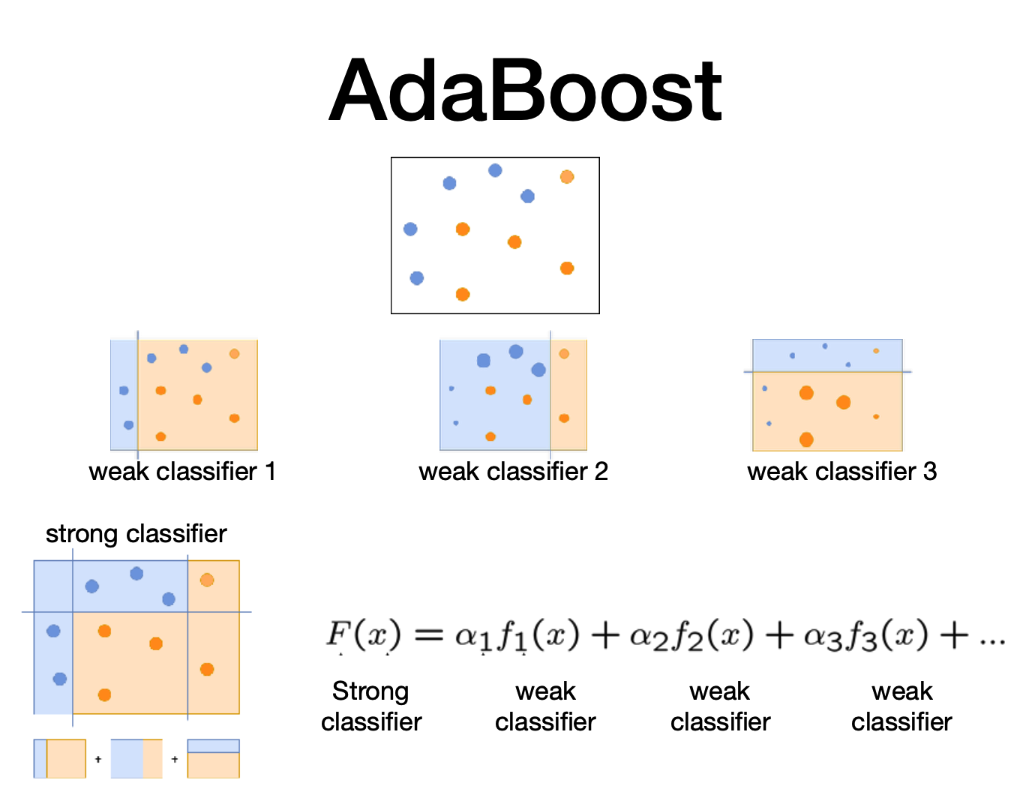

Viola and Jones (the first face detector) used AdaBoost to select the most relevant Haar features for face detection. During training, AdaBoost evaluates the performance of each feature and selects the ones that contribute most to correct classification. For example:

* One feature may measure intensity differences between eyes and cheeks.
* Another may compare eye regions with the bridge of the nose.

These selected features become part of the final detection model.

The cascade classifier is a **multi-stage classifier** system built using AdaBoost. It improves detection speed and accuracy by applying simple classifiers first to eliminate obvious non-face regions quickly. The image is divided into sub-windows. Each sub-window is evaluated by a sequence of classifiers (from simple to complex).

* A sub-window is immediately discarded if any stage classifies it as a non-face.
* Only windows that pass through all stages are classified as faces.

This structure makes the cascade classifier both efficient and effective.

Training the cascade classifier involves using **labeled datasets** of faces and non-faces. The faces are normalized to 24×24 pixels. AdaBoost is used to train each stage of the cascade, selecting the best features and thresholds. These trained classifiers are then applied to new images to detect faces in sliding windows.

Despite its effectiveness, the Haar cascade method has limitations. It can be tricked by changes in appearance such as makeup, occlusion, or unconventional facial patterns. An example is the “Anti Face,” where specific visual alterations render a face undetectable by the Viola-Jones Haar classifier. However, modern Deep Convolutional Neural Networks (DCNNs) are not affected by such issues and offer much higher robustness in face detection.

1. **ML4CV – 8a**

Machine Learning (ML) in CV is traditionally divided into two main paradigms: Supervised Learning and Unsupervised Learning.

* Supervised Learning relies on labeled data, where the goal is to **learn a function that maps input data x to labels y**. It is widely used in tasks such as classification, regression, object detection, semantic segmentation, and image captioning.
* Unsupervised Learning, on the other hand, uses data without labels. The goal here is to **discover hidden structures or patterns within the data**. Applications include region segmentation, image categorization, and color quantization.

As collecting labeled data is costly and time-consuming, the focus of modern ML is to reduce the amount of supervision required during model training. This has led to the emergence of alternative strategies:

* **Semi-Supervised Learning**: Combines a small amount of labeled data with a large pool of unlabeled data.
* **Weakly Supervised Learning**: Uses noisy or imprecise labels that may contain uncertainty.
* **Self-Supervised Learning**: Models generate their own supervision by predicting parts of the input from other parts, treating certain predictions as pseudo-labels.
* **Contrastive Learning**: A form of self-supervised learning where the model learns by distinguishing between similar (positive) and dissimilar (negative) examples.

**Clustering**, a core technique in unsupervised learning, involves organizing objects into groups (clusters) based on similarity:

* **Image segmentation**: Groups pixels of similar color or texture.
* **Image categorization**: Identifies similar images based on shared features.
* **Color quantization**: Reduces the number of distinct colors in an image, often for compression.

The key components of clustering are:

* **Data Representation**: Involves how input data is represented—may include raw features or learned representations via neural networks.
* **Similarity Measure**: A metric (e.g., Euclidean distance) that quantifies how similar two data points are. Small distance implies high similarity.

Clustering can be:

* **Partitional Clustering**: Divides data into non-overlapping subsets (e.g., K-means).
* **Hierarchical Clustering**: Builds a tree-like structure of clusters
* **Density-Based Clustering**: Forms clusters based on the density of points (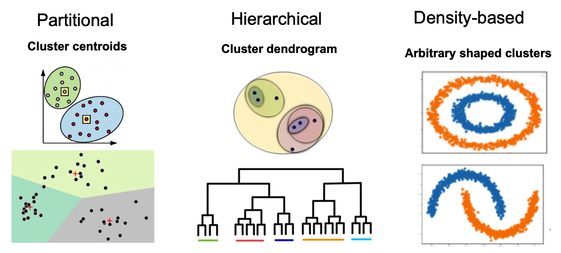

**K-means** clustering is a classical and still widely used algorithm **partitional clustering**. It partitions a dataset containing N data points into K clusters.

* Each cluster is defined by its mean or **centroid**.
* Every data point is assigned to the cluster whose centroid is nearest to it.

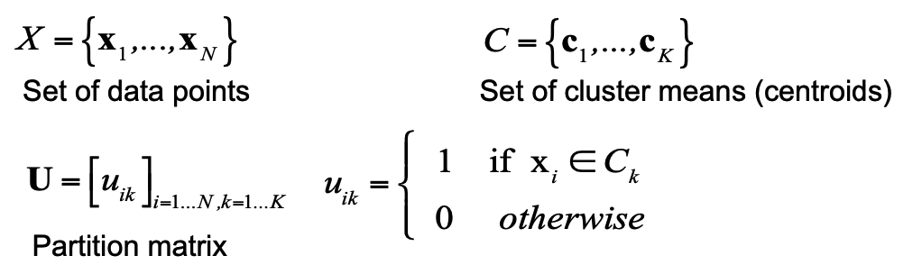

The goal of K-means is to **minimize the Sum of Squared Errors (SSE)**, the total distance of all points to their assigned cluster centroids. The cost function is:

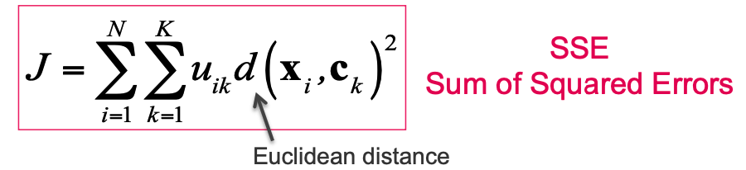

This optimization is performed through an **Expectation-Maximization (E-M)** approach:

* E-step (**Assignment**): Assign each data point to the closest centroid.
* M-step (**Update**): Recompute each centroid as the mean of all points assigned to it.

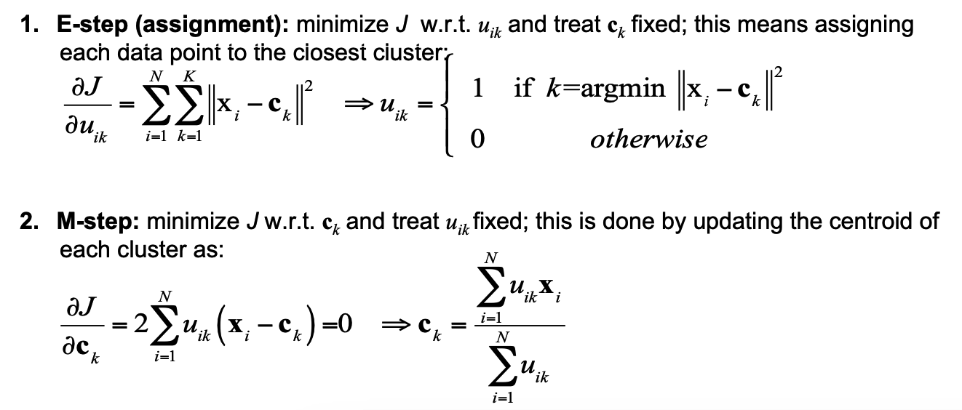

K-Means Steps:

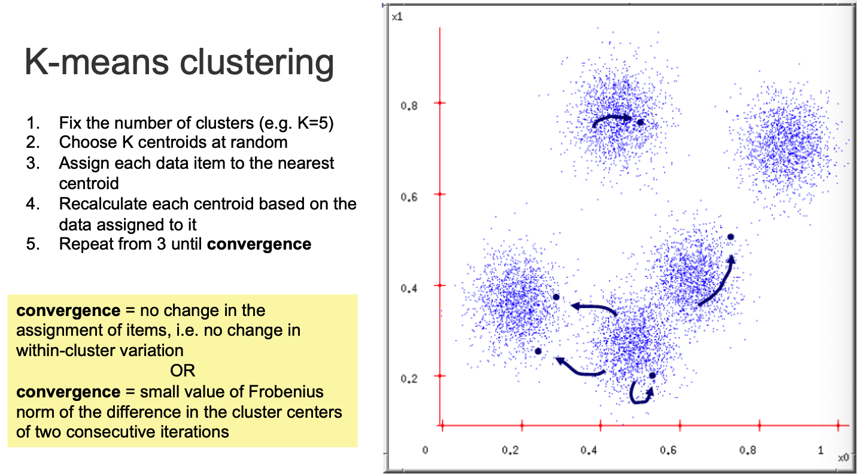

Different centroid initializations can lead to different results. The algorithm can get stuck in local minima. It is recommended to run K-means multiple times with different initializations and choose the result with the lowest SSE. Since K-means uses Euclidean distance, it is recommended to **standardize** **data** (mean = 0, std = 1) when feature scales differ.

Selecting the correct **number of clusters**, **K**, is a critical step in the clustering process. The **Elbow Method** is a heuristic used to determine the optimal number of clusters:

* For each value of K, run the clustering algorithm multiple times.
* Record the minimum value of the cost function (e.g., sum of squared distances).
* Plot K vs. cost and find the “elbow”: the point where additional clusters don’t significantly reduce the cost.

This elbow point indicates the best trade-off between underfitting and overfitting.

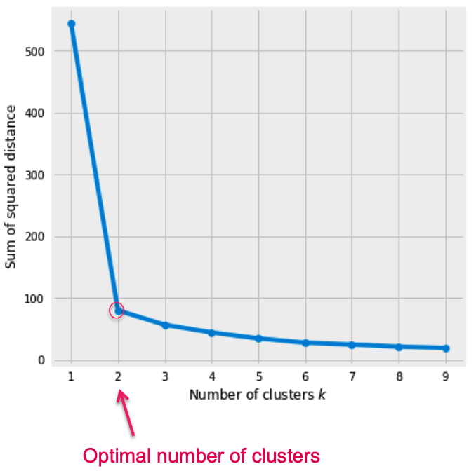

The goal of clustering is to produce:

* **Well-separated clusters**: Groups that are distinct from each other.
* **Dense clusters**: Internally compact groups of similar data.

This means achieving some internal mesaures:

* **High intra-cluster similarity**: Average distance between points within the same cluster (to be minimized).
* **Low inter-cluster similarity**: Average distance between points from different clusters (to be maximized).

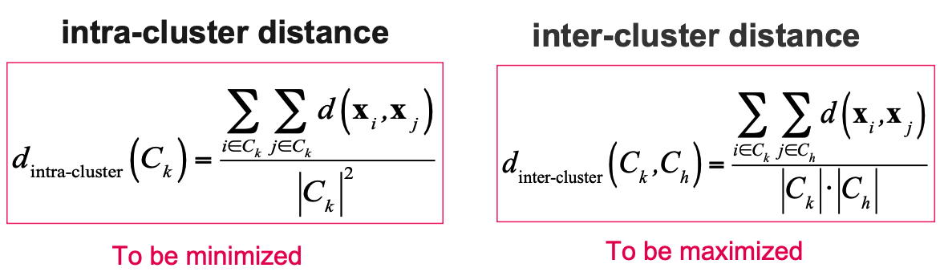

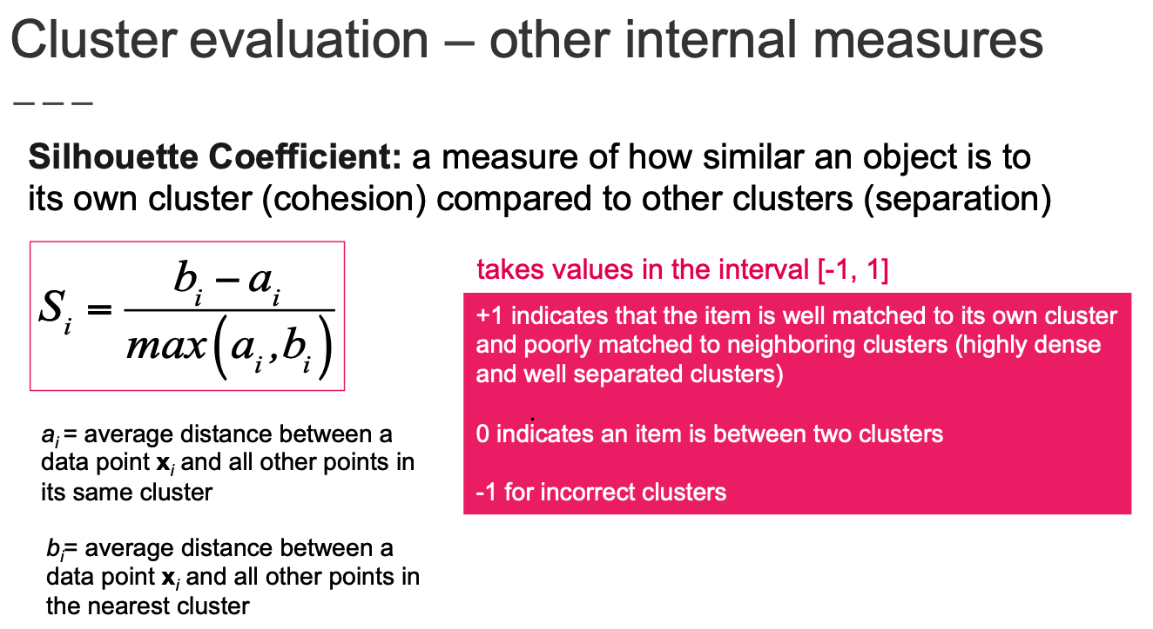

Besides quantitative metrics, qualitative measures (e.g., user judgment) can also assess clustering. However, these are subjective and hard to standardize. Instead, benchmarks or gold standards are used—datasets labeled based on consensus (known as **ground truth**).

**Purity** is an external evaluation measure:

* Assign each cluster to the most frequent class (dominant class).
* Purity is the proportion of total samples that belong to the dominant class of their cluster.

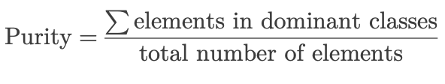

Traditional clustering algorithms like K-means assign each data point to exactly one cluster — this is known as crisp or **hard (crisp) clustering**. However, this approach struggles when clusters overlap. In overlapping regions, K-means cannot evaluate the uncertainty of the assignments. For example, points lying at the boundary of two clusters may be equally close to both, but K-means forces them into just one. With **Soft (Fuzzy) Clustering**, each point can belong to multiple clusters with varying **degrees of membership** between 0 and 1.

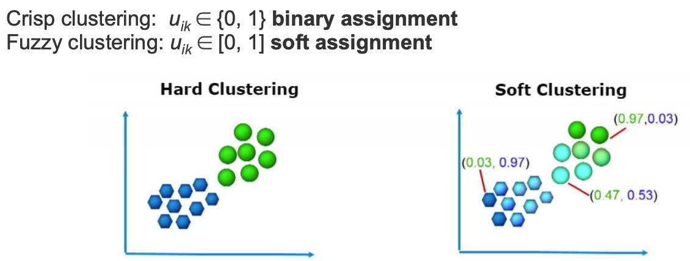

Proposed by Bezdek (1981), **FCM** is the fuzzy variant of K-means. It also uses Expectation-Maximization (EM) optimization to minimize the following cost function.

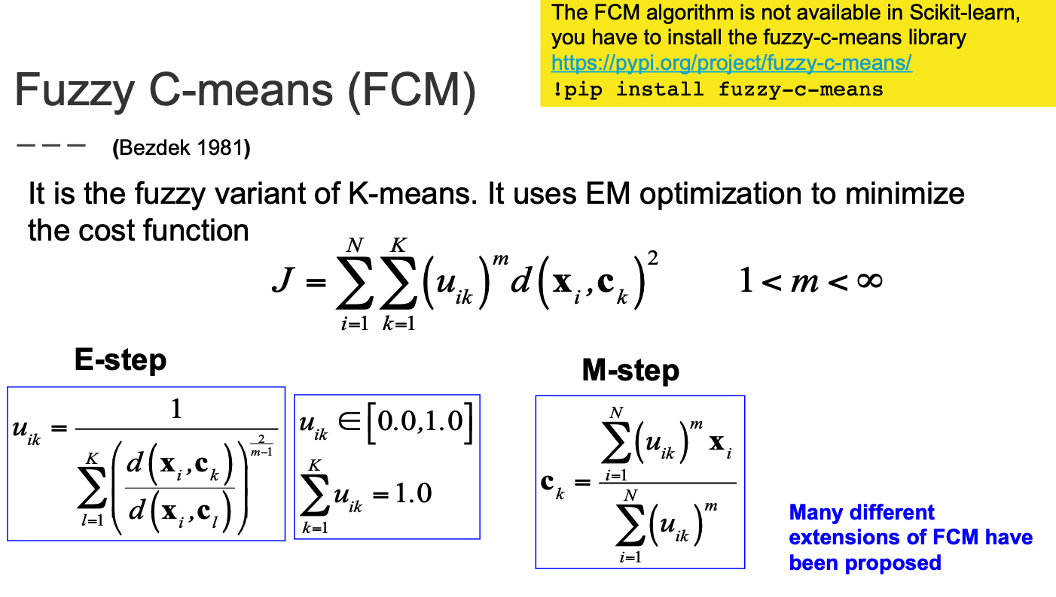

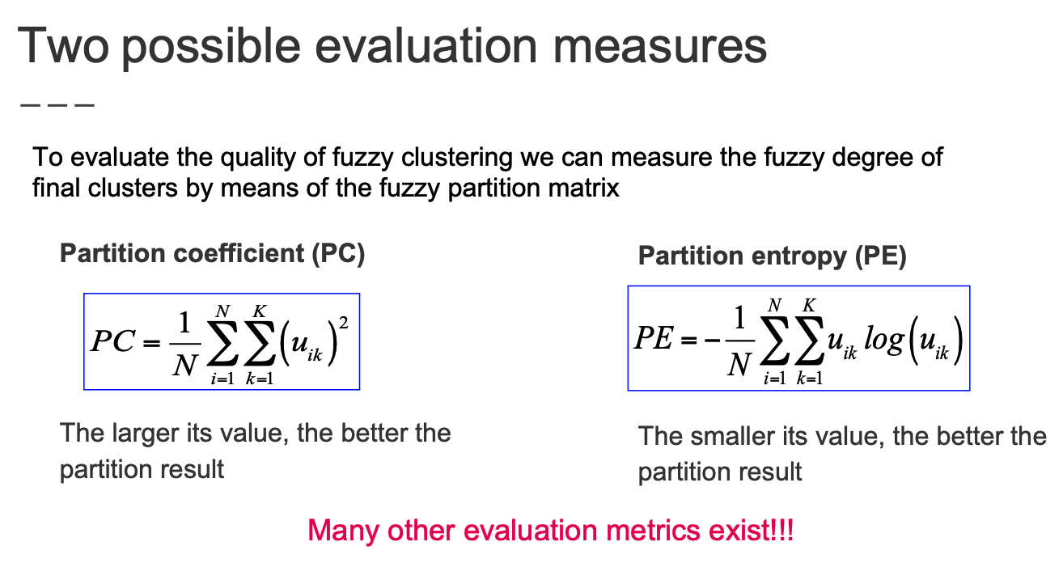

Lower values indicate better clustering (more certain assignments).

1. **ML4CV – 8b**

Understanding images is inherently complex due to the vast variability in how objects can appear. A single mathematical model cannot feasibly account for all variations in object appearance. This is in contrast to how humans learn to recognize objects—not by applying mathematical formulas, but through experience and exposure to millions of examples from the real world. This motivates a **data-driven approach** to **image classification**.

A data-driven image classification system learns directly from examples rather than predefined rules. The typical process follows these steps:

* Collect a labeled dataset
* Feature extraction
* Model training
* Model evaluation: Apply the trained model to new, unseen images to predict their labels.

The core goal of classification is to assign an input image x to one of M discrete classes **Ck**.

The general approach is probabilistic, estimating:

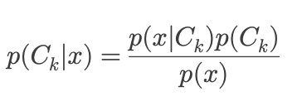

Classification can be:

* **Multi-class classification**: Each image belongs to exactly one class (e.g., a fruit image is either an apple or a pear).
* **Multi-label classification**: Each image may belong to multiple classes simultaneously (e.g., a landscape image might contain trees, clouds, and houses).

**K-Nearest Neighbors (K-NN)** is one of the simplest and most intuitive machine learning algorithms used for classification. It relies on the idea of comparing a new test image to the most similar examples in the training dataset. The simplest classifier (k=1) compares the test image with all training images and assigns the label of the closest match. This is known as the **Nearest Neighbor classifier**. To compare images, a distance metric such as **L1 distance** is used. This is computed by summing up the absolute differences between corresponding pixels in two images.

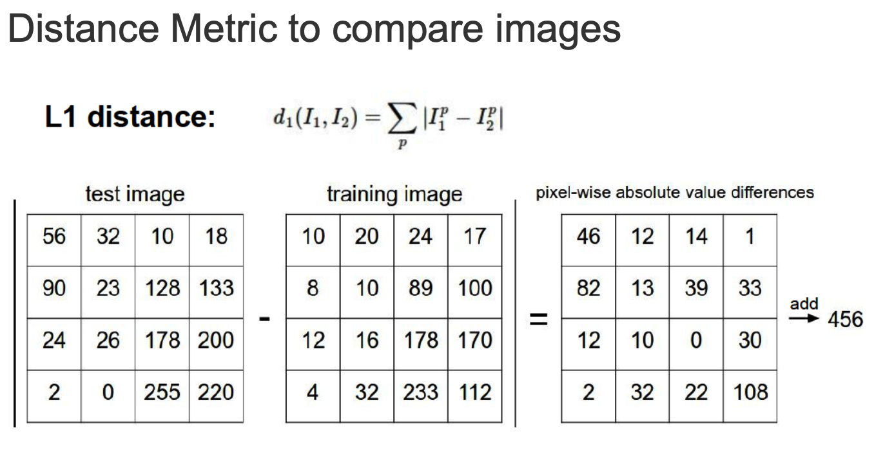

A more robust version of the nearest neighbor is the K-Nearest Neighbor classifier, which looks at the K most similar training examples and uses majority voting to assign a label.

It requires a lot of computation effort:

* Training time: O(1) (No actual training involved, just storing data)
* **Prediction time**: O(N), where N is the number of training samples.

It’s very important to choose the correct hyperparameters in K-NN:

* **K**: a small K is sensitive to outliers and noise in the data. A large K might include too many dissimilar neighbors, reducing accuracy. **Cross-validation** is a common technique used to determine the optimal value of K. For example, 5-fold cross-validation tests different K values and selects the one with the highest average accuracy.
* **Distance Metric**: Several distance metrics can be used (Euclidean, Cosine,…). It’s important to normalize the data, as features may be on different scales.

How to set the hyperparameters? Several strategies can be used:

* Choosing based on training performance (BAD: overfitting)
* Choosing based on test performance (BAD: no generalization check)
* Validation set strategy (BETTER)
* Cross-validation (BEST for small datasets)

To evaluate classifier performance, the following metrics are used:

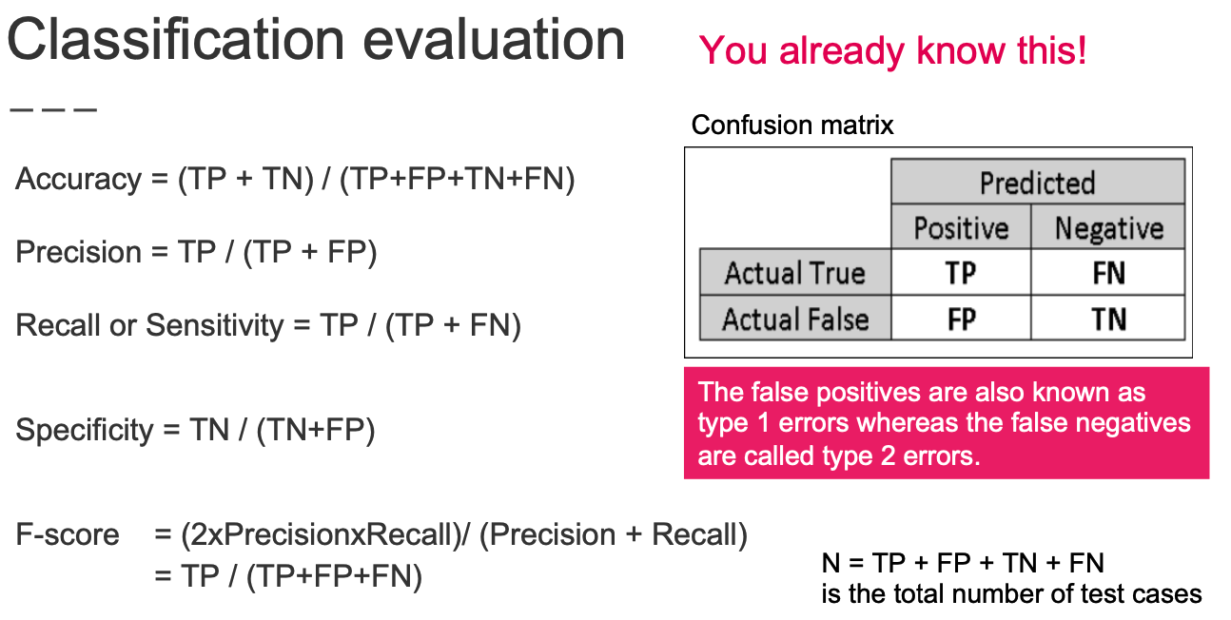

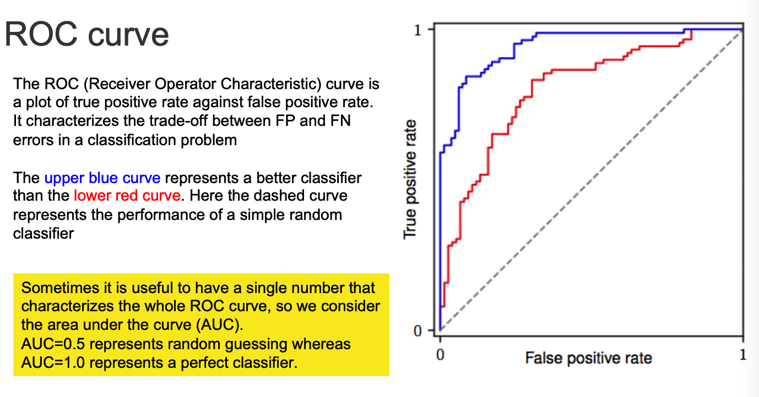

The K-Nearest Neighbors (K-NN) classifier is widely appreciated for its **simplicity**. It requires no training—just storing the dataset—and classifies new inputs by comparing them to all training examples using a chosen distance metric, like Euclidean distance. While this makes it extremely easy to implement and understand, it also brings some serious limitations.

One major issue is its high computational cost during **inference**. Each new test image must be compared with every single training image, making it very slow at test time. Additionally, K-NN is space inefficient: it must store all training data, which can be huge in real-world scenarios. Furthermore, using raw pixel values as features is problematic. Even slight changes—such as shifting, occluding, or tinting an image—can drastically affect the distance metric, even though the image content remains semantically the same. This illustrates that distance metrics on raw pixels are not informative. Therefore, it becomes necessary to represent images using more meaningful, invariant features.

To address these shortcomings, we transition from **non-parametric methods like K-NN** to parametric approaches, where we define a mathematical function with a fixed number of parameters. A common and powerful parametric model is the **linear classifier**.

In a linear classifier, we assume an image can be represented as a vector **x**, and we compute a score for each class using a linear function:

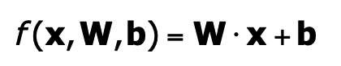

Here, W is a matrix of learned weights (one row per class), and b is a bias vector. The result is a vector of scores—one for each class. Each row of the weight matrix W can be seen as a template or prototype for a class. The classifier computes a score by evaluating how well the input image matches each template, using the dot product. This is often referred to as **template matching**. We also add a bias term **b**, which allows the decision boundaries to be more flexible. Without it, if the input x is zero, all scores would be zero—regardless of the learned weights. Let’s consider an example with only 4 input pixels and 3 possible classes (e.g., cat, dog, ship). The input vector x is multiplied by the weight matrix W, and a bias vector b is added. The result is a score for each class. The class with the highest score is selected as the prediction.

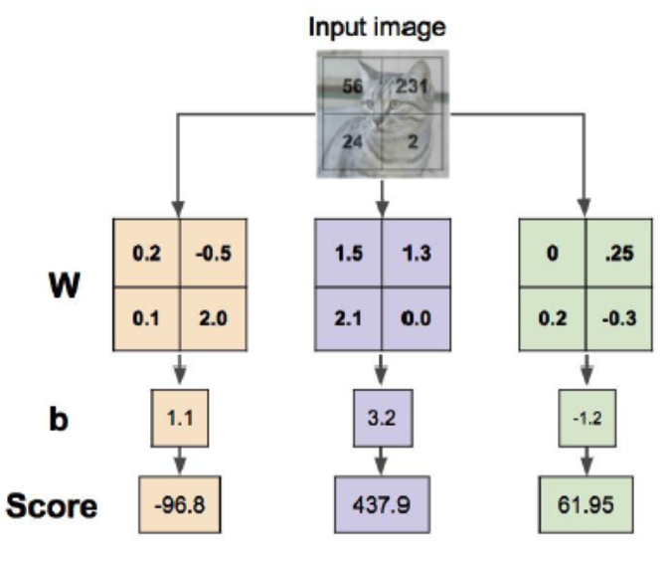

To simplify implementation, the bias term b can be absorbed into the weight matrix W. This is done by appending a constant 1 to the input vector x and extending W with an extra column. This trick transforms the equation to a form without an explicit b, making calculations more compact and efficient.

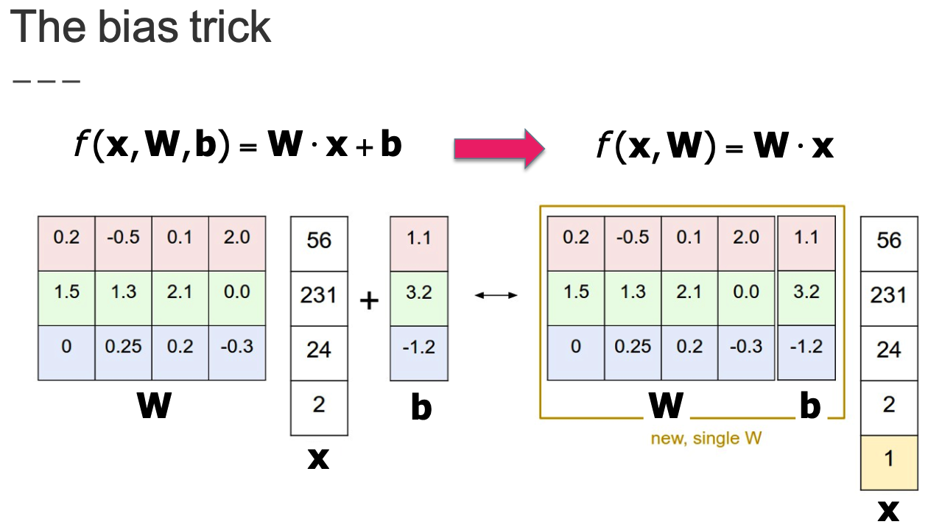

Linear classifiers work well when the data from different categories can be separated by straight lines or flat surfaces—this condition is known as **linear separability**. However, in many real-world scenarios, the relationship between input data and class labels is much more complex. In such cases, more advanced (non-linear) models are required to learn the true structure of the data.

1. **LOSS FUNCTIONS**

A loss function provides a numerical measure of how well the model’s predicted outputs align with the true labels. Minimizing loss is how we guide the model to improve during training.

Given a dataset of input-output pairs (xi, yi), the total loss over the dataset is the average of the individual losses computed for each data point:

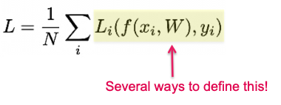

There are different ways to define this individual loss Li, and the choice depends on the type of classifier being used.

In binary classification with **Support Vector Machines (SVM)**, the goal is to find a hyperplane (weights w) that not only separates the two classes but also maximizes the margin—the distance between the hyperplane and the nearest data points from each class (known as **support vectors**). The SVM makes predictions using:



If the output is greater than zero, the model predicts one class; otherwise, it predicts the other.

To ensure the model not only predicts correctly but also with confidence, the **binary hinge loss** is used. This loss is zero only if the prediction is correct and at least a margin of 1 away from the decision boundary. Otherwise, it increases linearly the closer the point is to the boundary—or worse, if it’s misclassified.

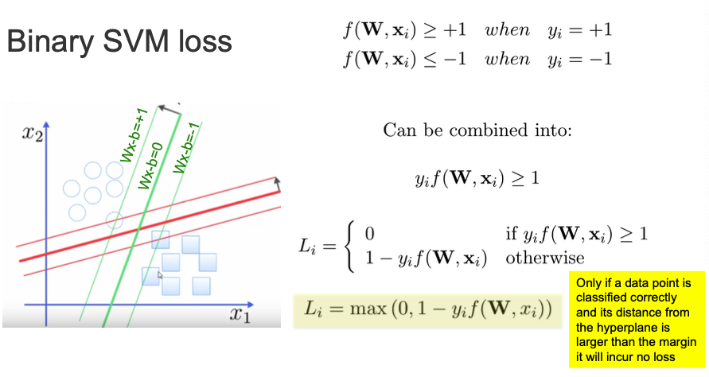

Extending hinge loss to multiclass problems leads us to the **Multiclass SVM Loss**, also known as multiclass hinge loss. Given the correct class yi for a data point xi, and scores sj for each class j we define the loss as:

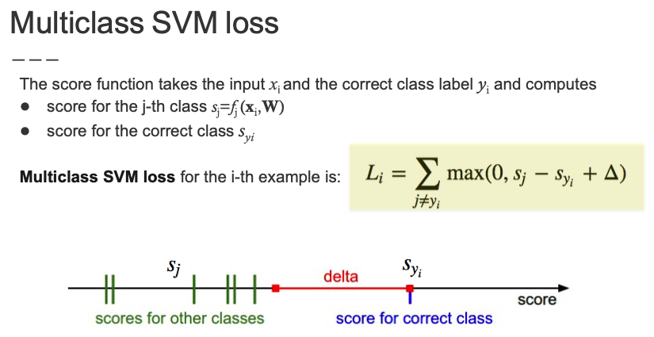

where delta is typically set to 1. This loss encourages the score of the correct class to be at least 1 greater than the scores of all incorrect classes. If this condition is not met, the loss will penalize the model accordingly. Even if the correct class has the highest score, but not by a large enough margin, the model is still penalized. This helps in building classifiers that not only get the label right but are also confident.

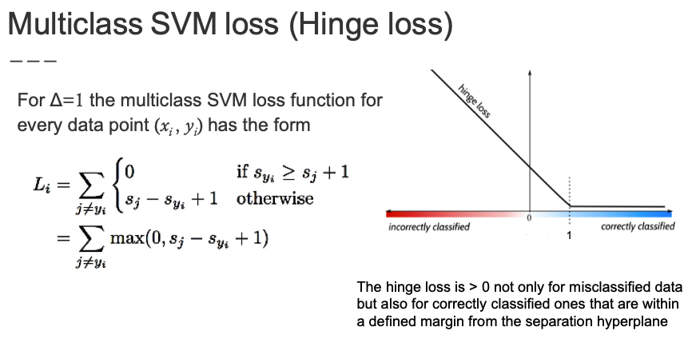

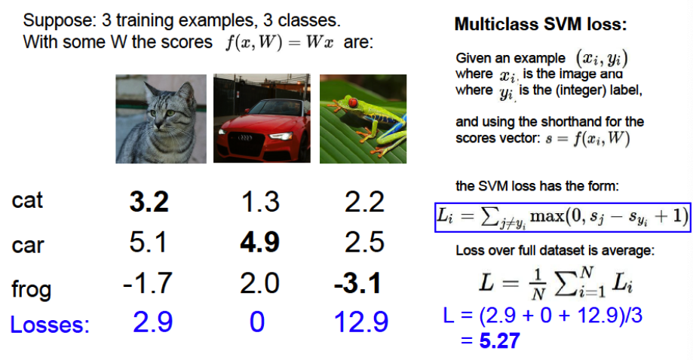

The **Softmax classifier** takes a different approach: instead of comparing margins, it interprets the class scores as probabilities via the softmax function:

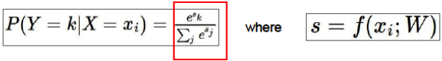

This converts the scores into a probability distribution over all possible classes. The corresponding loss function is the **cross-entropy loss**, which measures how far the predicted distribution is from the true one. It is defined as:

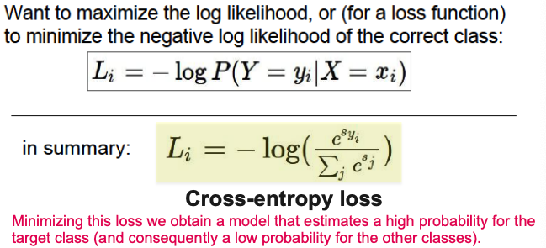

This loss is always **non-negative** and is minimized when the model assigns a high probability to the correct class. The logarithm penalizes incorrect predictions more sharply the more confident they are in the wrong direction.

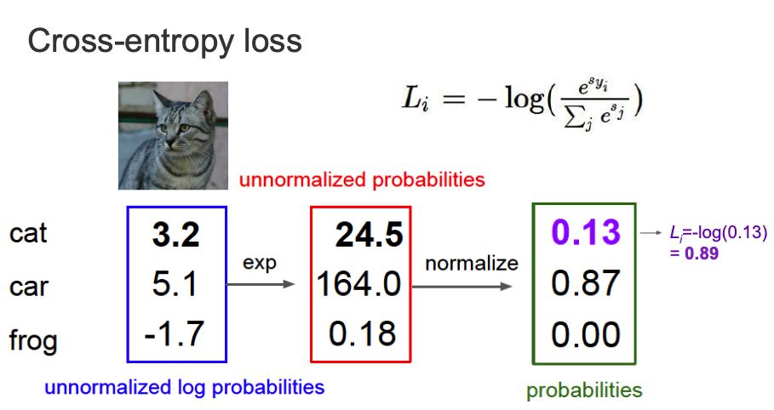

Our goal is to find the optimal set of weights W that minimize a given loss function. However, even if we find a weight matrix W that achieves **zero loss** (i.e., perfect separation of the classes), it may **not be unique**. In fact, any scalar multiple of W, such as 2W or λW for any λ>1, will also produce the same zero loss. This leads to a fundamental question: if multiple W’s result in the same loss, how does the model choose the “best” one?

To address this ambiguity, we introduce **regularization**. Regularization is a technique that adds a penalty term to the loss function, favoring simpler models—those with smaller weights. The full loss becomes:

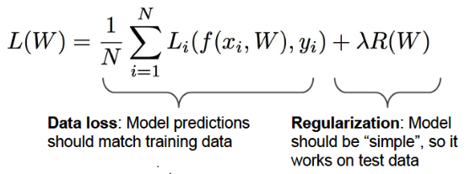

Here, R(W) is the regularization term, and λ is a hyperparameter that controls the strength of the penalty. Simpler models (e.g., those with smaller weights) are more likely to generalize better to unseen data, as they are less prone to overfitting. This is because smaller weights reduce the influence of any single input feature, helping the model focus on general patterns rather than memorizing the training set.

Regularization directly relates to the **bias-variance trade-off**:

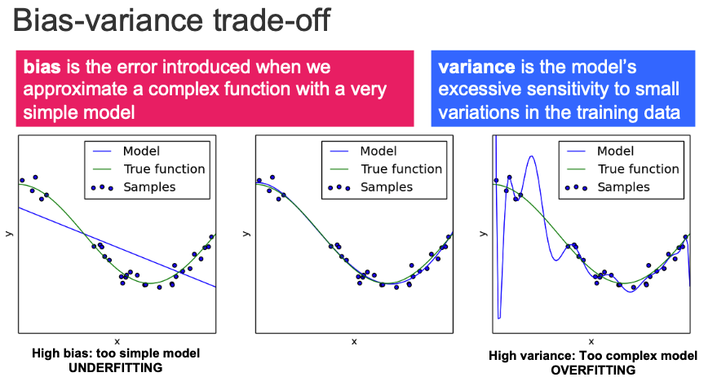

The ideal model lies in the sweet spot that balances both, which we can find by monitoring performance on a **validation set**. Too much complexity increases variance, while too much simplicity increases bias.

The most common forms of regularization are:

* L1 Regularization: Encourages **sparsity**, driving many weights to zero. This means the model tends to ignore less important features entirely, effectively performing feature selection. It can lead to simpler, more interpretable models.
* L2 Regularization: Encourages small, distributed weights (also known as **weight decay**). Instead of eliminating weights, it shrinks them smoothly, preventing any single feature from dominating the prediction. This helps improve generalization and reduce overfitting

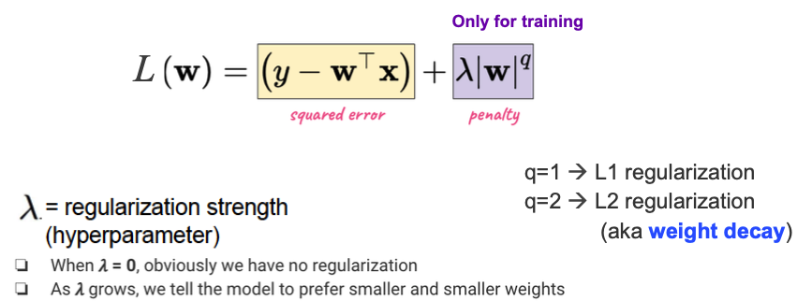

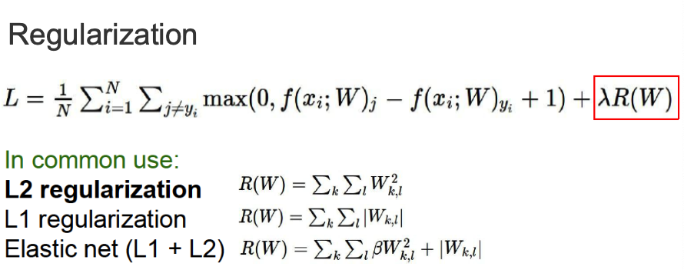

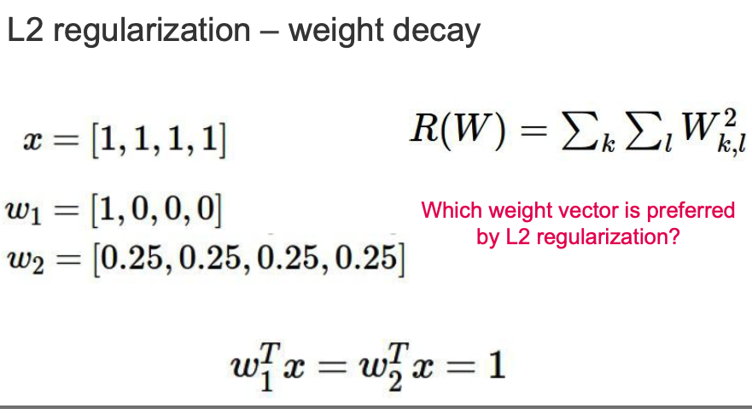

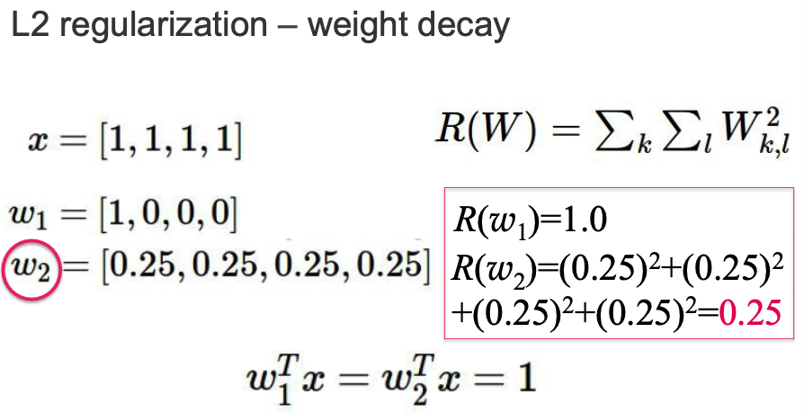

By integrating both data loss and regularization, we ensure that our model not only fits the training data but also maintains **generalization capability**—striking a balance between underfitting and overfitting.

A minimum of the loss function occurs where its **derivative (gradient)** is zero. The gradient tells us the slope or direction in which the function is increasing or decreasing. A positive gradient indicates an increasing function, and we should move in the opposite direction. A negative gradient means the function is decreasing, guiding us in the direction of minimization.

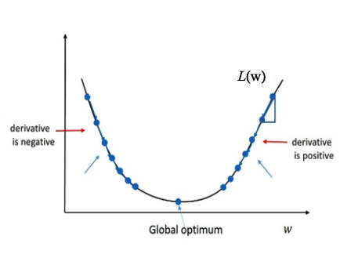

**Gradient Descent** is the optimization algorithm used to minimize the loss function. It works by iteratively adjusting the model’s parameters (weights) in the direction that reduces the loss.

Steps:

* Initialize weights randomly.
* Compute the loss and its gradient.
* Update the weights in the direction opposite to the gradient.
* Repeat the process until convergence.

The amount we move in each step is called the **step size** or **learning rate** (denoted η). Selecting a good learning rate is tricky. If it’s:

* Too small → The model learns very slowly.
* Too large → The model may oscillate around the minimum or diverge entirely.

Not all loss functions are smooth bowls. In reality, they can have complex, irregular landscapes with many local minima, plateaus, or saddle points. These characteristics can make finding the global minimum difficult.

Each complete pass over the training dataset is called an **epoch**. The maximum number of epochs is a **hyperparameter**. Ideally, after several epochs, the model learns a pattern that performs well on the training data.

Different strategies balance accuracy and efficiency:

* **Batch Gradient Descent**:
  + Uses the entire training set to compute the gradient.
  + Very accurate but computationally expensive for large datasets.
* **Stochastic Gradient Descent (SGD)**:
  + Uses one random training example at each iteration.
  + Fast and efficient but can be noisy and unstable.
* **Mini-batch Gradient Descent (common in deep learning)**:
  + Uses a small subset (batch) of training examples (e.g., 32 or 64).
  + Combines the efficiency of SGD with the stability of full batch updates.
  + Offers a good trade-off between speed and accuracy.

1. **NEURAL NETWORKS**

**Neural computing** is a biologically-inspired approach within the field of Computational Intelligence, designed to enable machines to learn from data by imitating how the brain processes information. This paradigm is based on the structure and function of the mammalian nervous system, with a particular focus on the brain. The human brain is an extremely complex system, composed of about 1010 to 1011 neurons. Each neuron can form up to 105 connections (**synapses**) with others. These vast interconnections allow neurons to work in parallel, enabling powerful information processing. Although each neuron acts like a simple processor, the brain’s strength lies in how these neurons are interconnected. Not only the number of neurons and synapses matters—the **topology** of the network, or the way neurons are arranged and connected, is key to the brain’s computational power.

Neurons communicate using both **electrical and chemical signals**. Each neuron receives inputs from other neurons, processes them, and, if the input signal is strong enough (i.e., if there’s a significant change in electrical charge), it sends an output signal to the next neurons in the network.

A biological neuron consists of several key components:

* **Dendrites**: Tree-like branches that receive input signals from other neurons.
* **Soma** (cell body): Contains the nucleus and processes the received signals.
* **Axon**: A long fiber that transmits signals from the soma to other neurons.
* **Synapse**: The point of connection where one neuron communicates with another.

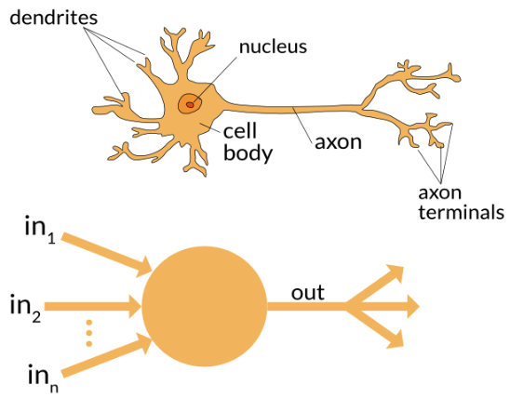

When a neuron receives a strong enough input through the dendrites, it generates an electrical impulse that travels down the axon and is transmitted to another neuron through the synapse.

An **Artificial Neural Network (ANN)** is a computational model that is conceptually inspired by biological neural networks. An ANN is made up of many artificial neurons that are interconnected in **layers**. A notable research in this field is the **Blue Brain Project**, launched in 2005. It digitally reconstructs and simulates the mammalian brain. An artificial neuron simplifies the functioning of a biological one. It is essentially a processing unit that receives inputs (like signals from other neurons), processes them through a weighted summation, adds a bias (threshold), and then passes the result through an activation function to produce an output.

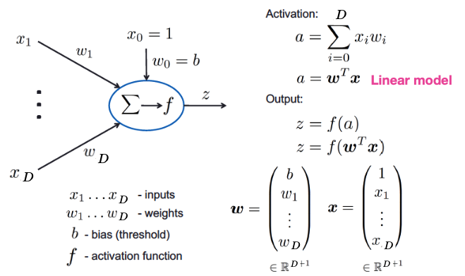

Basic elements of an artificial neuron:

* **Synapses** (**weights**): Each connection has a numerical strength (weight).
* **Adder**: Sums the input signals, weighted by synaptic strength.
* **Activation function**: Limits or shapes the output.
* **Bias**: A constant added to the weighted sum, shifting the activation threshold.

The first mathematical model of an artificial neuron was introduced by McCulloch and Pitts in 1943. Known as the **Threshold Logic Unit**, it functioned by summing weighted inputs and outputting a binary result depending on whether the sum surpassed a certain threshold.

The **Perceptron** is the simplest algorithmically defined neural network. It consists of a single neuron that uses a Heaviside step function as its activation function (Threshold Logic Unit). Mathematically, the perceptron computes an activation value (a) and then applies the threshold function. The output y = f(a) is **binary**, classifying the input as belonging to one of two classes. This makes the perceptron a linear classifier.

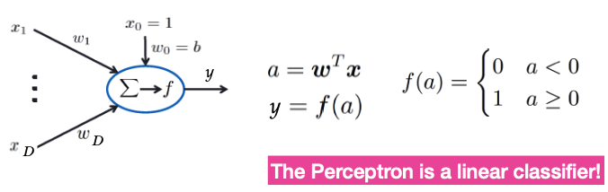

The perceptron is the first example of **supervised learning**. Given a training set of input-output pairs (x(i), y(i)), the goal is to **adjust the perceptron’s weights and bias** so that the output better matches the target labels. The learning rule is simple: for each training sample, compare the output of the perceptron with the correct label. If the prediction is wrong, update the weights:

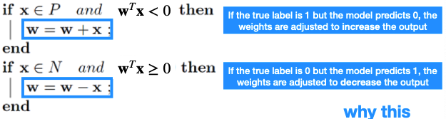

The learning rule can also be interpreted geometrically using the **dot product:**

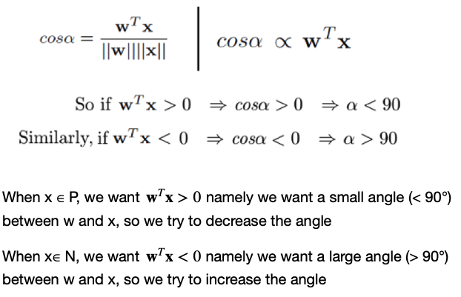

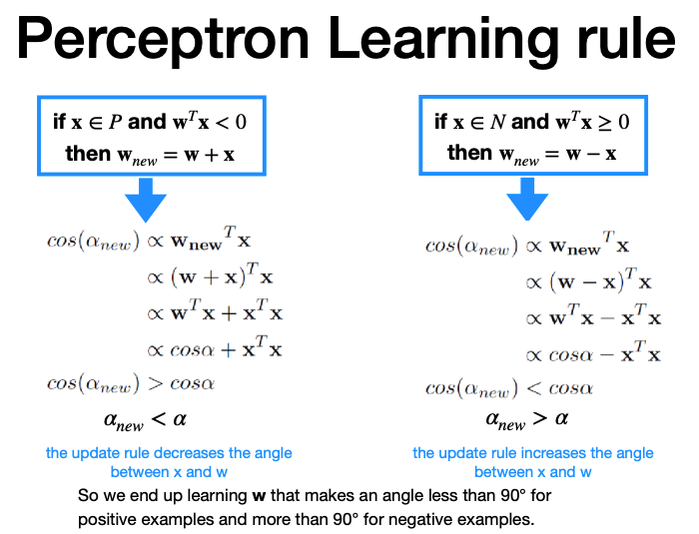

The first practical application of the perceptron was **digit recognition**. Since the perceptron is a binary classifier, one perceptron was used per digit. The first physical implementation was the **Mark I Perceptron**. This machine was connected to a 20x20 camera (producing 400 pixels) and could recognize letters of the alphabet.

Despite its simplicity and historical importance, the perceptron has a significant limitation: it can only learn problems that are **linearly separable**. That means it can only find a solution if a single straight line (or hyperplane in higher dimensions) can separate the two classes. Mathematically, this requires:

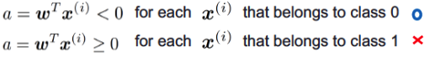

If the data is not linearly separable, the algorithm does not converge. One famous example is the XOR problem, which cannot be solved by a single-layer perceptron. To overcome these limitations, researchers extended the perceptron to include multiple layers. A network of many perceptrons (i.e., multiple neurons arranged in layers) forms what we now call an **artificial neural network (ANN)**, capable of solving more complex, non-linear problems.

In an ANN, some nodes are designated as **input nodes**, which receive data from the outside world. These are connected to **hidden nodes (internal processing units)**, which in turn connect to output nodes that provide the final result. The strength of each connection is represented by a **weight**, which is adjusted during training. There are various ways to organize the nodes and their connections:

* **Feedforward Neural Network (FNN)**: Information flows in one direction—from inputs to outputs—with no cycles.
* **Recurrent Neural Network (RNN)**: These include loops, allowing information to persist across steps.

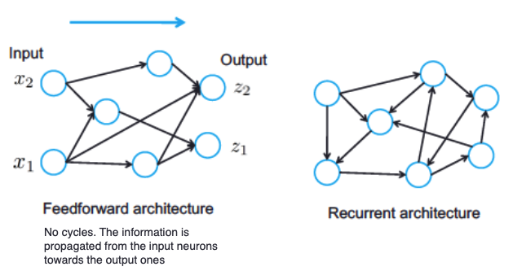

A Feedforward Neural Network consists of an input layer, one or more hidden layers, and an output layer. The hidden nodes are not directly observable; they serve to transform the input through layers of abstraction. In a Single-layer Perceptron, there is only one layer between inputs and outputs. It is limited to learning linearly separable functions. In a Multi-layer Perceptron (MLP), **additional hidden layers** allow the network to learn more complex, non-linear functions. Hidden layers enhance the capacity of the network to learn non-linear functions. This is also called **representation learning**, where each hidden layer transforms its input into new, non-trivial representations.

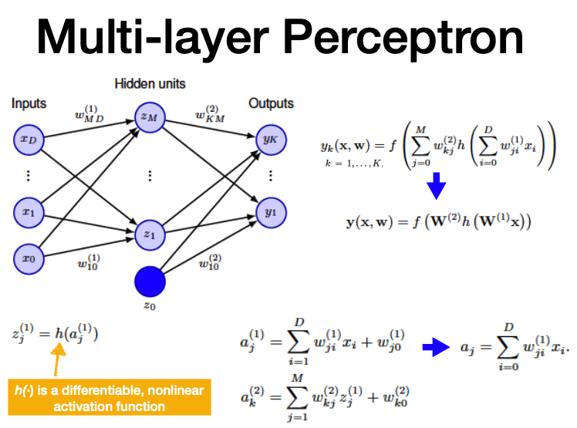

Components:

* **x** is the input vector. x0=1 is the **bias.**
* **D** is the number of real input features (excluding the bias).
* **wji** joins xi with yj
* **wkj** joins zj with yk.
* **M** is the number of hidden neurons

aj(1) is the **linear combination** of inputs. It is the activation value of each hidden neuron zj.

Each output neuron computes its own activation using the outputs of all hidden neurons:

ak(2) is the activation at the output layer.

Finally, we apply an activation function **f()** at the output to get the final prediction. The result is a **nonlinear parameterized function**. This concept can be extended to networks with multiple layers. For layer l, the transformation is:

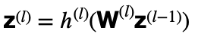

This shows how data is transformed step-by-step from input to output, with each layer applying a weighted transformation followed by a nonlinearity.

According to the **Universal Approximation Theorem**, a neural network with at least one hidden layer and a nonlinear activation function (e.g., sigmoid) can approximate any continuous function with arbitrary precision. This was formally proved by Cybenko in 1989.

However, while this guarantees that such a network exists, it doesn’t specify how to build it or how many neurons are needed. In practice, designing effective networks often requires experimentation and trial and error.

A Multi-Layer Perceptron (MLP) is defined by its **architecture**, which includes the **number of layers and the number of neurons per layer**. These are called **hyperparameters**.

While choosing the input and output layers is often straightforward, determining the number and size of hidden layers requires more intuition and experimentation.

The number of hidden neurons is especially important:

* Too many can lead to **overfitting**
* Too few can lead to **underfitting**

There is no universal rule to determine the right number of hidden nodes, but common strategies include:

* Empirical tuning (e.g., trial and error)
* Pruning/growing methods

Training is done using supervised learning:

* A dataset of input-output pairs (training set) is used.
* For each input, the network predicts an output, compares it with the true label, and adjusts the weights accordingly.

The learning process follows these main steps:

1. Present an input.

2. Compute the output of the network (**forward pass**).

3. Compute the error.

4. Update the weights based on the error (**backward pass**).

5. Repeat until the error is minimized.

The training goal is to minimize the loss function, which measures the difference between predicted outputs and true targets. A common choice is the **sum of squared errors**

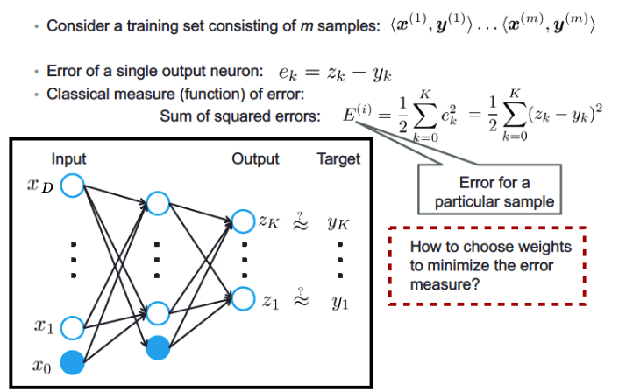

Since there is no closed-form solution for minimizing this function, **gradient descent** is used, often with optimizers like Adam.

**Backpropagation (BP)** is the most widely used algorithm to train Multi-Layer Perceptrons. It is based on gradient descent, and its objective is to minimize the error at the output of the network by adjusting the weights through the gradient of a loss function.

BP consists of two main phases:

* **Forward pass**: computes the output of the network given an input.
* **Backward pass**: computes the gradient of the loss function with respect to each weight by applying the chain rule of calculus, then updates the weights.

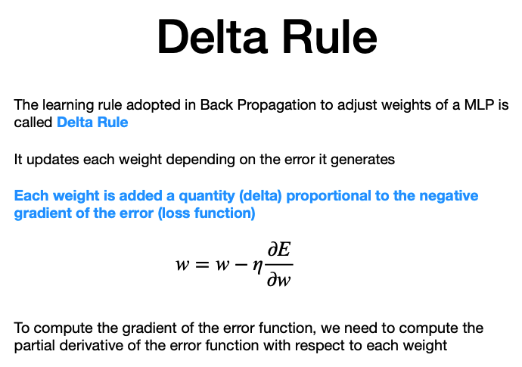

* w: weight
* n: learning rate
* partial derivative of the error with respect to the weight

Each weight is updated by subtracting a quantity proportional to the negative gradient of the loss with respect to that weight. This computes how much each **weight contributed to the overall error**, using the partial derivative of the error with respect to that weight.

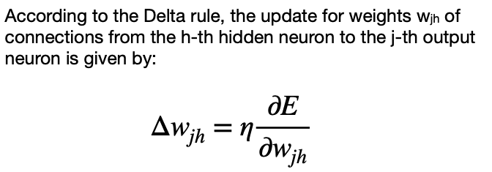

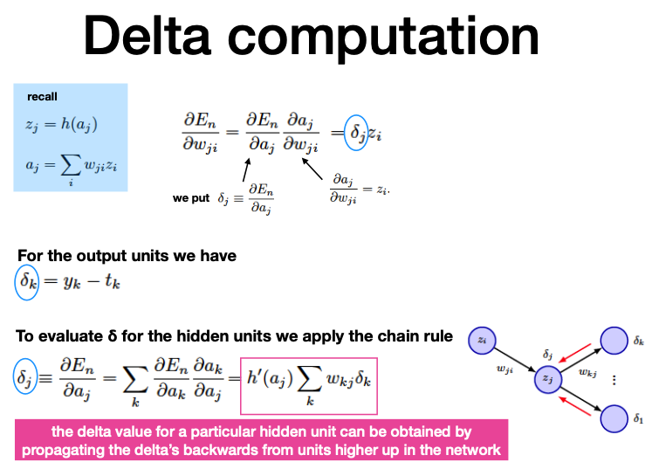

The delta (δ) measures the **contribution of a specific neuron to the total error of the network**. It tells us how responsible that neuron is for the error, and thus how much its incoming weights need to be adjusted.

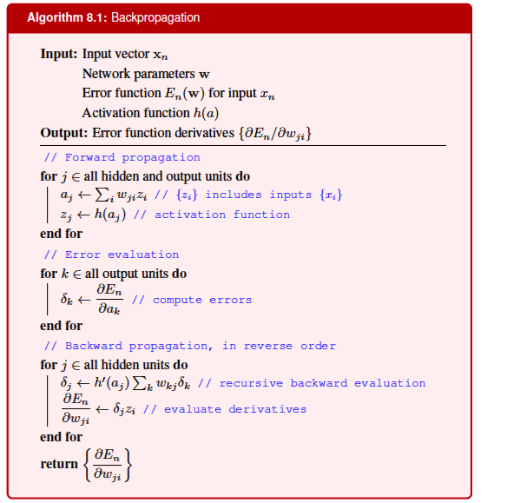

When using **batch or mini-batch training**, we sum the gradients over all samples in the batch:

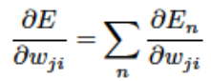

With **Stochastic Gradient Descent (SGD)**, instead of updating weights after each sample, we can do it after a mini-batch:

* Sample a batch of training data.
* Forward prop: compute outputs and loss.
* Backprop: compute gradients using backpropagation.
* Update weights using averaged gradients.

The **learning rate** is a critical hyperparameter in training neural networks using gradient descent. It determines the size of the steps taken towards the minimum of the loss function.

* If η is too small, the updates to the weights (Δw) will be tiny, leading to very slow convergence.
* If η is too large, updates may overshoot the minimum, causing the optimization process to become unstable or to diverge.

A well-chosen small η ensures smooth changes in weights and stable convergence. In practical systems, **adaptive learning rates** are used to adjust η dynamically during training (e.g., learning rate schedules or optimizers like Adam).

Proper initialization of weights is essential to break symmetry and enable effective learning:

* **Random initialization (typically near zero)** ensures that neurons in the same layer start differently and learn different features.
* If all weights are initialized identically, neurons will compute the same outputs and gradients, preventing the model from learning effectively.

**Input features** should be **standardized** to have zero mean and unit variance. This normalization step ensures that the network receives well-scaled data, which stabilizes learning.

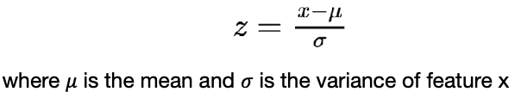

Choosing the right number of **hidden layers** and units is vital:

* Too few hidden units → **underfitting**: the model cannot capture data complexity.
* Too many hidden units → potential **overfitting**: the model memorizes the training data.

When unsure, it’s safer to use more hidden units and apply **regularization techniques**.

In deep MLPs, gradients propagated through many layers can shrink exponentially, especially with activation functions like **sigmoid**. As gradients become small, weights stop updating effectively, halting learning. This is known as the **vanishing gradient problem**. Sigmoid activations compress inputs into a range between 0 and 1. When inputs are too positive or too negative, the gradient of the sigmoid becomes very close to zero. This leads to:

* “Saturated” neurons that stop learning.
* Very inefficient training in deep networks.

To solve this, alternative activation functions are used (for example ReLU).

Neural networks are prone to **overfitting**, especially with many parameters. Several techniques help reduce overfitting:

* **Regularization**
* **Early Stopping**: Monitors the validation error during training. Stops process when validation error stops improving for a some number of epochs **(patience criterion)**, saving time and improving generalization.

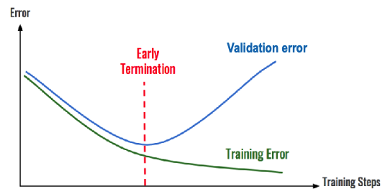

* **Dropout:** Randomly “drops” (ignores) hidden neurons during training. This neurons are used then as a regularizer.

1. **CONVOLUTIONAL NEURAL NETWORKS**

**Fully connected neural networks** (also known as Multi-Layer Perceptrons or MLPs) connect each neuron in one layer to every neuron in the next. While powerful for many tasks, they face critical limitations in visual tasks such as image recognition:

* **Loss of Spatial Information**: When using a fully connected NN for image input, the image must first be flattened into a 1D vector. This process destroys the spatial structure of the data—i.e., the relative positions of pixels—which is crucial for interpreting visual patterns.
* **Need for Handcrafted Features**: MLPs require a well-defined and informative set of features. For perceptive tasks, it is not always clear which features should be extracted. Identifying these features manually is extremely complex.

Traditional image processing approaches relied on hand-designed features like HOG, SIFT, or Haar features. These are based on human intuition and fixed mathematical formulations, but they **can’t generalize** well to large variations, such as changes in lighting, orientation, and background.

Research in neuroscience (e.g., Huber & Wiesel, 1959) showed that human visual perception is based on **hierarchical** feature extraction:

* Early stages detect edges and lines.
* Middle stages recognize patterns and shapes.
* Final stages assemble those into objects and scenes.

This inspired the design of **Deep Neural Networks (DNNs)**, where each layer learns progressively more abstract features from the raw input. In vision tasks, early layers may detect edges or textures, while deeper layers recognize faces, whiskers, or entire objects.

In traditional Machine Learning, the process is split:

* Step 1: **Handcraft or compute a set of features** from the input.
* Step 2: **Use those features** in a classifier.

In Deep Learning, this boundary disappears:

* **A single model** performs both feature extraction and classification. The system learns the best features directly from raw data through multiple layers during training.

This end-to-end learning paradigm removes the need for expert-designed features and lets the model adapt its internal representation to the specific task.

**Convolutional Neural Networks (CNNs)** are a type of neural network particularly effective for processing images. A typical CNN is composed of four main building blocks:

* **Convolution**: Filters (also called kernels) slide over the input image, computing local dot products to generate activation maps (feature maps).
* **Non-Linearity (ReLU)**: A non-linear activation function is applied to retain only significant activations.
* **Pooling (or Subsampling)**: Reduces spatial dimensions while preserving important information, helping prevent overfitting.
* **Fully Connected Layers**: The extracted features are flattened and used for final classification.

Their name comes from the convolution operator: it is used to **extract feature** from an image by preserving the **spatial relationship between pixels**. The image window covered by the filter is the **receptive field** of the neuron. The parameters of the filter are the **weights** associated to the neuron.

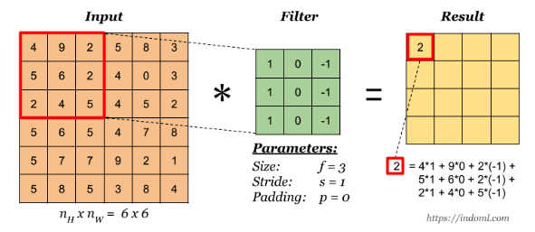

To control the output size:

* Zero padding adds zeros around the border of the image.
* **VALID** convolution: no padding → smaller output.
* **SAME** convolution: padding added to preserve input size.

For color images (e.g., RGB), the convolution is applied to all channels simultaneously. Each filter spans all input channels (e.g., 5×5×3 for a 3-channel image). Results from each channel are summed to generate the final output.

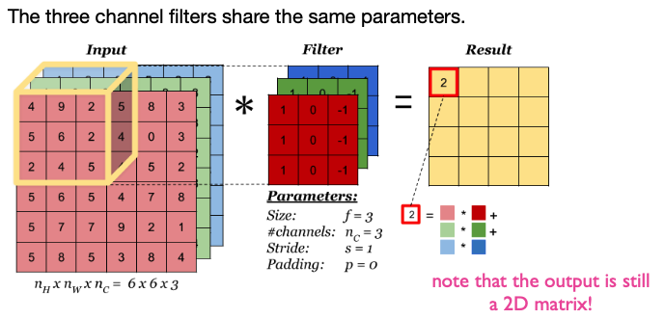

Each **convolutional layer**:

* Applies the **same filter** at all spatial locations of the input.
* Produces a **feature map** by sliding the filter and computing local dot products.
* Can contain multiple filters **(m filters)**, each learning a different feature → results in **multiple feature maps**.The number 𝑚 of filters is also called the **depth** of the output volume made of feature maps.

Unlike fully connected layers, neurons in a convolutional layer are not connected to all input neurons. They have **sparse connections** restricted to their **receptive fields**.

In CNNs, instead of learning a unique set of weights for every neuron (as done in fully connected networks), **weight sharing** means all neurons in the same feature map use the same filter (i.e., the same weights). This dramatically reduces the number of trainable parameters. For instance, a 5×5 filter in a 32×32×3 image used 10 times will still only have 76 parameters (including bias), not 760 distinct sets.

Advantages of **weight sharing**:

* **Parameter Efficiency**: Fewer parameters mean the model is **less prone to** **overfitting** and more computationally efficient.
* **Translation Invariance**: If a filter detects a pattern in one location, it will detect it anywhere in the image since the same filter is used everywhere.

In a CNN, **layers are** **stacked** such that each subsequent layer receives as input the feature maps from the previous layer. This enables hierarchical feature learning:

* Lower layers capture basic patterns (edges, textures),
* Middle layers capture parts of objects,
* Higher layers recognize full objects or classes.

This local connectivity combined with hierarchical structure makes CNNs especially effective for image recognition.

To allow CNNs to model complex, non-linear patterns, a non-linear activation function is applied after each convolution. The most common is the **Rectified Linear Unit (ReLU):**

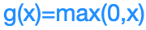

RELU replaces all negative pixel values in the feature map by **zero** and prevents the **vanishing gradient problem.**

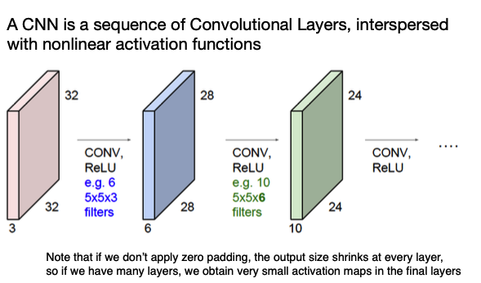

**Spatial Pooling** (aka subsampling/downsampling) reduce the size of feature maps while retaining important features. This has several benefits:

* **Reduces Parameters**: Fewer neurons, less computation.
* **Improves Generalization**: Reduces overfitting.
* **Invariance to Small Distortions**: Makes features more robust to translation or noise.

There are different types of Spatial Pooling (Max, Average, Sum), but the most used is **Max**.

Each pooling neuron operates independently and has **no weights**. The pooling layer has **two hyperparameters**: the **size** of the filter and the **stride** (common setting F=2, S=2 or F=3, S=2).

Pooling operates independently over each **feature map**, meaning that the number of channels remains unchanged after pooling. Each pooling neuron is connected only to a limited region (its **receptive field**) in the previous layer and performs a simple operation—most commonly the maximum or average value within that region.

CNNs are composed of several key building blocks arranged in a specific pattern:

* Multiple **convolutional layers** extract local features from input data using learnable filters.
* **ReLU (Rectified Linear Unit) layers** introduce non-linearity, allowing the network to model complex functions.
* **Pooling layers** reduce spatial dimensions while retaining critical information, improving computational efficiency and invariance to minor input shifts.
* After multiple CONV+RELU+POOL blocks, the final layers are usually **fully connected** **layers**, which perform the final classification (e.g., via softmax).

As we move deeper into the network:

* **Feature maps become smaller** in spatial size.
* **Feature depth increases**, capturing more abstract and higher-level features.

While both Fully Connected Neural Networks (FNNs) and CNNs contain neurons with learnable weights and apply nonlinearities:

* **CNNs preserve spatial locality**, capturing local pixel correlations thanks to convolution.
* **FNNs flatten inputs**, losing spatial information, and are unable to generalize across spatial translations.
* CNNs are thus better suited for image data due to their **local connectivity** and **weight sharing**.

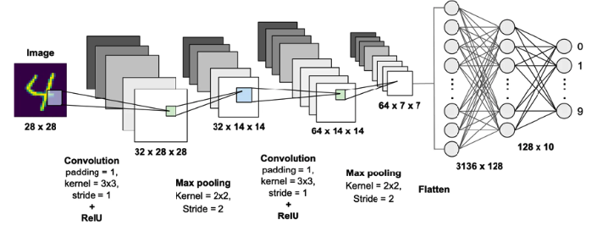

For **training**, CNN training uses Stochastic Gradient Descent (SGD) or its variants to minimize a loss function. The training process includes:

* **Forward propagation** to compute output predictions. (convolution, ReLU, pooling and fully connected layer for forward propagation).
* **Loss calculation** based on prediction vs. true labels.
* **Backward propagation** to compute gradients of filters and weights.
* **Weight update** using the gradients.

The entire process is repeated across training epochs to minimize prediction error.

To stabilize and speed up training, **Batch Normalization** is used:

* Normalizes the inputs of a layer to have a **consistent distribution**.
* Usually placed **after a CONV/FC layer and before the activation function**.
* Reduces sensitivity to initialization and acts as a **regularizer**.

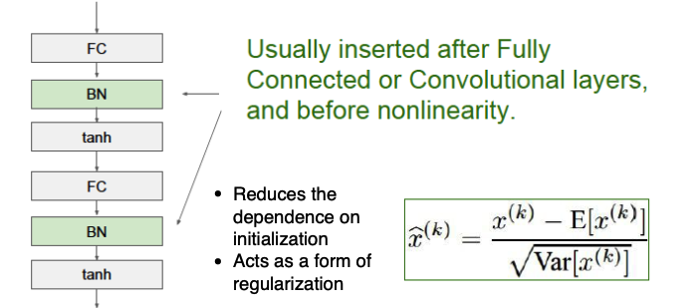

CNNs require careful tuning of several **hyperparameters**, including:

* Number, size, and depth of convolutional layers.
* Filter size and stride.
* Pooling type and size.
* Learning rate, batch size.
* Dropout rate and number of fully connected layers.

This tuning can significantly impact performance and training efficiency.

There are some important CNN like LeNet, AlexNet, VGG16. But, there are some limitations.

High number of parameters leads to:

* Increased **memory requirements**.
* **Risk of overfitting**, especially with small datasets.
* Need for **expensive GPU** resources.

Several deep network architectures have been proposed to reduce the number of parameters like Inception (GoogleNet), ResNet and so on. These models prioritize **Sustainable AI** and enable real-time applications even on limited hardware.

Deep neural networks (DNNs) require:

* High **computational power**, even with GPU acceleration.
* **Large amounts of labeled data**, which is expensive and time-consuming to obtain.

These limitations highlight the need for alternative strategies such as **Transfer Learning** and **Data Augmentation.**

Transfer learning addresses the high cost of training DNNs by **reusing knowledge from previously trained models**. Instead of training a network from scratch, a pretrained CNN (e.g., trained on ImageNet) is used to extract features. The convolutional base of the pretrained network is reused, while a **new classifier is trained on top**. This leverages generic features learned by the lower layers, which are generally transferable across tasks.

Data augmentation introduces **variability in the training data** by applying transformations such as:

* Geometric: crop, rotation, flip, scale
* Photometric: brightness, contrast, hue
* Occlusion or noise

This approach makes models more robust and helps **prevent overfitting**.

Two main augmentation strategies:

* **Offline augmentation**: transformations are pre-applied and stored. Preferred for smaller datasets.
* **Online augmentation**: transformations are applied during training on-the-fly. Preferred for larger datasets, as in this case oﬄine augmentation gives an explosive increase of the dataset.

1. **AUTOENCODERS - GANs**

**Generative modeling** is a branch of machine learning that focuses on training models to generate new data samples that are similar to those in a given dataset. The goal is to learn a probability distribution **pmodel(x)** that closely approximates the true distribution of the training data **pdata(x)**. Once learned, the model can generate new samples that are indistinguishable from those in the training data.

Generative models differs from discriminative models:

* **Discriminative models** (e.g., classifiers) learn to map inputs to labels: **p(y|x)**. They can recognize patterns but they cannot generate new samples.
* **Generative models**, instead, learn **p(x)** and allow the generation of new samples resembling those in the training data. They focus on learning the underlying structure of the input data to generate new, plausible instances from random noise, estimating **p(x).** Because no labels are required, generative modeling typically falls under **unsupervised learning**.

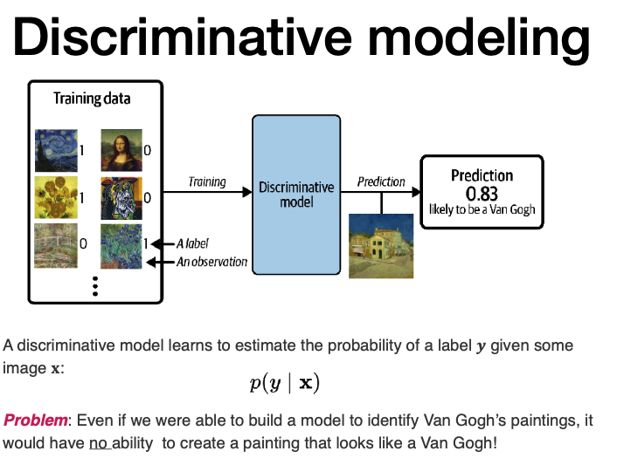

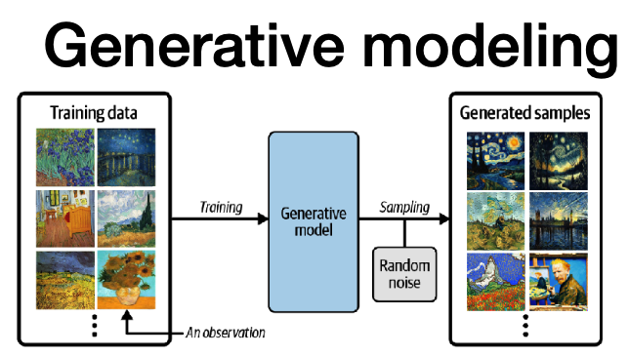

Image generation is extremely difficult due to the **enormous number of possible combinations of pixel values**. Yet, only a tiny fraction of these combinations represent **meaningful images**. A generative model must learn to recognize and replicate this tiny subset of “realistic” images.

Generative modeling is deeply connected to **probability density estimation**—estimating the likelihood of data occurring in a given distribution. This can be tackled in two ways:

* **Explicit estimation (Autoencoders)**: The model defines and samples pmodel(x) directly.
* **Implicit estimation (GANs)**: The model learns to generate data from pmodel(x) without defining it explicitly.

Autoencoders are a class of neural networks designed for unsupervised learning, whose primary goal is to learn **how to compress and then reconstruct input data**. They consist of two parts:

* **Encoder**: which compresses the input into a simpler **latent space** with a condensed vector called **embedding**. It learns to extract important features by applying **convolutional layers** and **pooling** to reduce dimensionality.
* **Decoder**: which reconstructs the original input from this compressed representation. It uses **transposed convolutions** (also called **deconvolutions**) to reconstruct the input.

The training objective is to **minimize the reconstruction loss**, typically measured by the mean squared error (MSE) between the original input and its reconstruction:

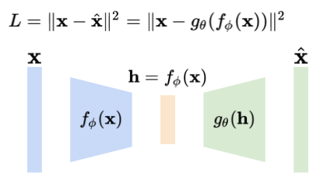

Autoencoders are mainly tested by:

* **Reconstructing inputs** from a test set and comparing them to the originals.
* **Generating novel images**: by sampling new points in the latent space and decoding them. However, since the latent space is not regularized, the generated images may not always look realistic.

Autoencoders **excel at reconstruction** but are **not ideal for generation**. To overcome these limitations, **Variational Autoencoders (VAEs)** were introduced.

**Variational Autoencoders (VAEs)** are an extension of traditional autoencoders that incorporate **probabilistic modeling** into the encoding process. Unlike standard autoencoders, which encode each input image into a **single deterministic** vector in the latent space, VAEs encode each image into **a distribution**—specifically, a multivariate Gaussian defined by **two vectors**: **mean (μ)** and **variance (σ)**.

During training, a latent vector **z** is sampled from this distribution:

**z = μ + σ × ε, where ε ~ N(0,1).**

This technique allows the model to be differentiable and trainable via backpropagation.

The decoder in VAEs is the same as in classic autoencoders and is responsible for reconstructing the image from the sampled latent vector.

The VAE training loss combines two terms:

* **Reconstruction Loss**: Measures how well the output matches the input.
* **Kullback–Leibler (KL) Divergence**: It measures how much one probability

distribution diﬀers from another. It is a regularization term that encourages the learned latent distributions to be close to a standard normal distribution N(0,1) because it penalizes the network for encoding images to μ and σ vectors that diﬀer significantly from the parameters of a standard normal distribution.

In this way, VAEs generate a **well-structured and smooth latent space**, enabling meaningful image generation by sampling from the learned Gaussian distributions.

VAEs are powerful tools for a variety of tasks:

* **Data Denoising**: Clean noisy inputs by reconstructing the original signal.
* **Data Augmentation**: Generate realistic new samples by sampling from the latent space.
* **Anomaly Detection**: Train the model on normal data; anomalies will yield high reconstruction errors, indicating a deviation from the learned distribution.

**Generative Adversarial Networks (GANs)** are a powerful class of generative models capable of learning the distribution of training data and generating new data that looks similar. They consist of **two neural networks trained simultaneously** in an adversarial setup:

* **Generator (G)**: Trained using **unsupervised learning**, it takes random noise as input and produces synthetic data (e.g., fake images).
* **Discriminator (D)**: Trained using **supervised learning**, it distinguishes between real data (from the training set) and fake data (from the generator).

The goal of the generator is to create data that is indistinguishable from real data, while the discriminator aims to correctly classify inputs as real or fake. This creates a competitive game between the two, where the generator improves at fooling the discriminator, and the discriminator improves at spotting fakes. The generator has no direct access to the training data of the discriminator but it only learns through the feedback from the discriminator.

**Discriminator Training**:

* Task: **Binary classification**—label 1 for real images, 0 for fake.
* **Data**: A mix of real images from the dataset and fake images from the generator.
* Loss Function**: Binary cross-entropy** to improve its ability to distinguish real from fake.

**Generator Training**:

* Task: **Generate images** that fool the discriminator.
* Data: **Random vectors** from a standard normal distribution.
* Loss Function: **Binary cross-entropy**, **but with labels set to 1**.

DCGANs are a specialized type of GAN that use **convolutional layers**:

* Generator: **A deep CNN** that maps noise to images.
* Discriminator: A CNN binary classifier that distinguishes real from fake images.

1. **DIFFUSION MODELS**

Diffusion models are a class of generative AI models that can create images from textual descriptions. In recent years, they have gained massive popularity due to their ability to outperform GANs (Generative Adversarial Networks) in several tasks such as image generation, inpainting, super-resolution, and colorization.

Popular diffusion models include DALL·E, Imagen, and Stable Diffusion. These models work by taking a prompt and generating a realistic or artistic image that reflects that prompt.

The term “diffusion” is inspired by thermodynamic diffusion, where particles (e.g., atoms, molecules) spread from high concentration areas to low concentration ones due to thermal motion. In the context of machine learning, a diffusion model systematically adds noise to data (like images) in small steps (called **forward diffusion**) and then learns how to reverse this process (**reverse diffusion**) to reconstruct the data. The model becomes proficient at generating data by mastering this denoising process.

The model does two main operations:

* **Forward diffusion**: progressively adds noise to an image.
* **Reverse diffusion**: gradually removes noise to retrieve or generate the original image.

Forward diffusion is a Markov chain that progressively adds Gaussian noise to an image x_0, creating intermediate noisy versions x_1, x_2, …, x_T, where x_T is pure Gaussian noise.

Over time, the image becomes increasingly noisy. When t approaches infinity, the result is nearly indistinguishable from random noise. The reverse diffusion is learned during training. The goal is to start from pure noise and learn how to reconstruct an image through a denoising process. At each step, the model predicts a less noisy version of the image, moving from x_T back to x_0.

Diffusion models share similarities with autoencoders, but with key differences. In autoencoders:

* The encoder maps input data to a latent space.
* The decoder reconstructs the original data.

In diffusion models:

* The forward diffusion acts like an encoder, but it’s not learned—it’s fixed.
* The reverse diffusion acts like a decoder and is learned via a neural network.

The **schedule** determines how noise is added over time.

* **Linear schedule** adds the same amount of noise at each step. This may lead to redundant noise in later steps.
* **Cosine schedule** adds noise more gradually, which improves the quality of the reverse process.

The core neural architecture used in many diffusion models is the U-Net. It consists of:

* **Down-sampling blocks** that extract spatial features using convolutions.
* A **bottleneck** with **attention blocks** to capture global features.
* **Up-sampling blocks** that reconstruct the image using transposed convolutions.
* **Skip connections** to retain high-resolution features from earlier layers.

OpenAI improved the basic U-Net for DALL·E 2 by increasing depth, reducing width, and adding attention layers.

To make the process faster and more efficient, latent diffusion models operate not on the image directly, but on its **latent representation**.

This is done by wrapping the diffusion model inside an autoencoder:

1. The encoder transforms the image into a compact latent space.

2. The diffusion process runs on the latent representation.

3. The decoder reconstructs the image from the denoised latent.

DALL·E 2 is a powerful diffusion-based generative model introduced by OpenAI in 2022. It can generate high-quality images from a prompt.

DALL·E 2 is composed of three main components:

* **Text Encoder**: Converts the natural language prompt into a numerical vector called a text **embedding**. Based on **CLIP** (Contrastive Language-Image Pretraining), also developed by OpenAI.
* **Prior Model**: Transforms the text embedding into a corresponding image embedding. This step aligns textual and visual semantic spaces.
* **Decoder**: Uses the image embedding to generate the final image via a diffusion model. It denoises a latent variable step-by-step until it becomes a realistic image.

CLIP is a multimodal model that connects text and images. CLIP learns a shared embedding space for both images and text. During inference, it can:

* Find the image that best matches a given text.
* Or find the text that best matches a given image.

CLIP is not a generative model—it does not produce images or text. Instead, it is a **discriminative model** used for matching and understanding cross-modal relationships.

CLIP uses a technique called **contrastive learning** during training. The idea is to teach the model which pairs of text and image match, and which do not.

Each training sample has:

* An **anchor** (e.g., an image)
* A **positive sample**
* A **negative sample**

The model is trained to:

* **Minimize** the distance between the anchor and the positive.
* **Maximize** the distance between the anchor and the negative.

To train CLIP, two separate encoders are used:

* A Text Encoder, which is typically a **Transformer**.
* An Image Encoder, usually a **Vision Transformer (ViT**).

These encoders are jointly trained so that both text and images are projected into the same embedding space. This allows CLIP to compare them directly using similarity measures, such as cosine similarity.

CLIP is trained with a **contrastive loss**, which operates on batches of image-text pairs. In each batch:

* Each image is paired with a matching text (the correct description).
* The model then compares all image-text combinations in the batch.

The training objective is to:

* Maximize similarity for the correct pairs (**on the diagonal** of the similarity matrix).
* Minimize similarity for all incorrect combinations (**off-diagonal**).

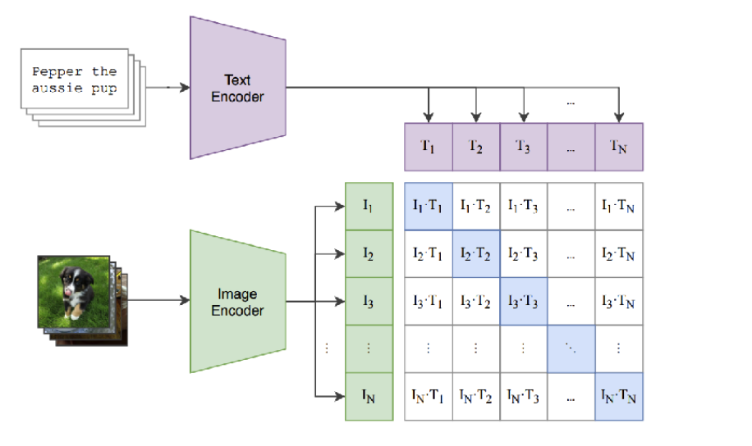

After training, CLIP demonstrates **zero-shot learning**.

The **prior model** transforms the text embedding into a corresponding image embedding. This step enables the connection between linguistic and visual representations. The prior is a diffusion model itself. During training, text and image embeddings (from CLIP) are concatenated and the image embedding is gradually noised. The prior learns to denoise the image embedding, conditioning each step on the text embedding.

Once the image embedding is ready, the decoder (a **U-Net diffusion model**) generates the final image from noise.

DALL·E 2 can generate multiple variations of the same image.

To do this, it first encodes the image using the CLIP image encoder to get the image embedding. Then it feeds this embedding into the DALL·E decoder along with different noise **seeds** (optional: also guided by a new text prompt). The result is a set of visually similar images with different styles or perspectives.

Despite its power, DALL·E 2 has some known limitations:

**Attribute Binding Issues**: It struggles to correctly associate attributes to the right objects.

E.g., for the prompt “A red cube on top of a blue cube,” the colors or positions may be wrong.

**Text Generation Flaws**: It performs poorly at rendering legible text, even when explicitly prompted (e.g., signs or labels often contain gibberish).

DALL·E 3 improves upon the DALL·E 2 framework by using a **frozen large language model (LLM)**, like GPT, to interpret the text prompt.

To evaluate image generation models, we use **FID – Fréchet Inception Distance**.

FID measures the distribution difference between real and generated images.

It compares the mean and covariance of feature vectors extracted by Inception v3 (a CNN).

Lower FID = more realistic and high-quality generated images.

1. **SEMANTIC SEGMENTATION**

Semantic segmentation is the task of dividing an image into meaningful parts, where each pixel is classified based on the object category it belongs to.

This is a **pixel-level classification task**: the model must predict a class label for every single pixel in the image.

Training data consists of paired images and pixel-wise annotations, where each pixel is labeled with a semantic category (e.g., grass, cat, tree…). At test time, the model predicts the label of each pixel in a new image.

One intuitive idea is to:

* Encode the whole image using a convolutional neural network (CNN).
* Perform segmentation at the output layer.

However, standard CNNs used for classification often **reduce spatial resolution** through pooling layers. This is a problem for segmentation, which requires that the output has the same resolution as the input.

To address this issue, researchers proposed **Fully Convolutional Networks (FCNs)**:

* These networks only use convolutional layers (no fully connected layers).
* They avoid downsampling the feature maps too much, or they upsample them again using transposed convolutions.
* The network produces a segmentation map that matches the input size.

SegNet is a classic encoder–decoder architecture for segmentation:

* It uses convolution + batch normalization + ReLU blocks.
* The decoder uses pooling indices from the encoder to guide upsampling.
* The final output is passed through a softmax layer for pixel-wise classification.

U-Net is the state-of-the-art architecture for deep semantic segmentation. It consists of:

* A **contracting path** (downsampling) to capture context.
* An **expanding path** (upsampling) to enable precise localization.

There are different types of segmentation tasks:

* Instance Segmentation: Labels each object instance separately.
* Semantic Segmentation: Labels each pixel with a class, not caring about instances.
* Panoptic Segmentation: Combines both semantic and instance segmentation.
* Part Segmentation: Segments object parts (e.g., cow’s head, legs, body).

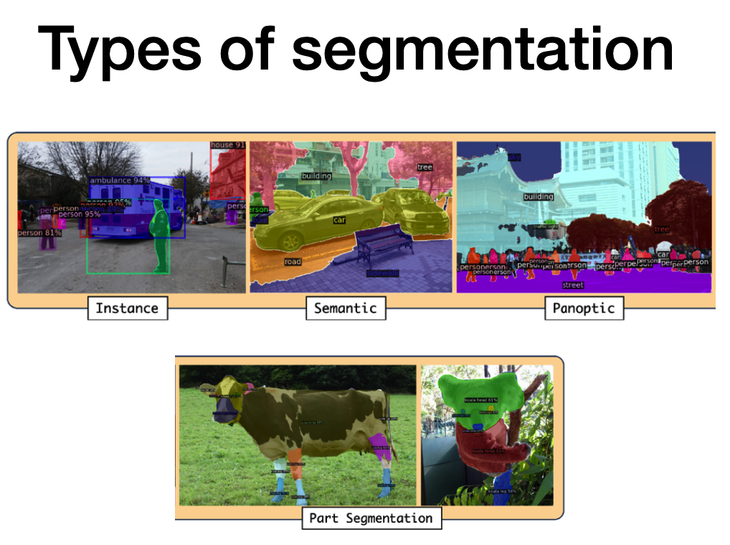

SAM is a cutting-edge model introduced by Meta AI.

Its goal is to enable **universal segmentation**: given any kind of prompt (point, box, text, etc.), it produces a segmentation mask for the specified object.

How SAM Works:

* The **image encoder** (a ViT) generates embeddings.
* The **prompt encoder** converts input prompts into a compatible representation.
* A **lightweight mask decoder** combines both embeddings to produce segmentation masks.
* The model outputs multiple masks with confidence scores.

**Object detection** consists in finding bounding boxes that locate the target object location.

The quality of an object detector is usually evaluated by comparing the predicted bounding boxes with the ground-truth ones. The most widely used metric for this is the **Intersection over Union (IoU)**, which measures the area of overlap between the predicted and actual bounding boxes divided by the area of their union. If the IoU is above a predefined threshold (commonly 0.5), the detection is considered a True Positive (TP). Otherwise, it is a False Positive (FP).

An object detection model typically has two tasks: classifying the object (**classification**) and predicting the bounding box coordinates (**regression**). This makes it a multi-output model. The classification head usually uses a softmax or sigmoid activation function for multi-class classification, while the regression head outputs normalized box coordinates using a sigmoid activation.

In the case of detecting a single object, the architecture is relatively simple: the image passes through a CNN, which outputs both a class prediction and the bounding box coordinates. Localization is treated as a regression problem, and the loss function is a combination of classification loss (e.g., softmax cross-entropy) and localization loss (e.g., L2 loss on bounding box coordinates). However, when multiple objects are present in an image, the problem becomes more complex. Each image may contain a different number of objects, requiring the model to output a variable number of predictions. A naive approach involves applying a CNN to multiple crops of the image and classifying each crop as an object or background. This brute-force strategy, while conceptually simple, is computationally expensive due to the large number of crops needed at various scales and locations.

To overcome this, two main strategies have been developed:

* **Region proposal-based methods**: These methods first generate potential object-containing regions (region proposals), then classify each region. This approach is accurate but slow.
* **Regression-based methods**: These single-stage methods perform detection in one pass through the network, directly predicting bounding boxes and associated class probabilities. They are faster and offer good accuracy.

One of the earliest region proposal-based methods is **R-CNN** (Region-based Convolutional Neural Network). It uses a Selective Search algorithm to generate about 2000 region proposals per image. Each region is passed through a CNN, and the resulting features are used for bounding box regression and object classification using SVMs.

To improve efficiency, **Fast R-CNN** was introduced. Instead of feeding each proposal through the CNN individually, the entire image is passed through the CNN once. Feature maps are extracted, and **RoI** (Region of Interest) pooling is used to extract fixed-size feature vectors for each region proposal. These are then passed through fully connected layers for classification and bounding box regression. This drastically reduces computation time.

**Mask R-CNN** builds upon Fast R-CNN by adding a third branch for predicting segmentation masks. In addition to class labels and bounding boxes, the model also outputs a binary mask for each object, enabling instance segmentation.

**YOLO** is a popular **regression-based** method for real-time object detection. The core idea is to process the entire image just once and predict all bounding boxes and class labels in one go — hence the name.

How YOLO Works:

* The image is divided into a grid.
* Each cell in the grid predicts multiple bounding boxes and their associated confidence scores.
* A class confidence score.

YOLO’s architecture has three main parts:

* Backbone: A CNN that extracts features from the input image.
* Neck: A set of layers that aggregate and refine the features.
* Head: Outputs the predictions — bounding box coordinates and class probabilities.

Face detection typically follows a two-step process:

Detect the face in the image, often using HOG features or a CNN. Detect facial landmarks, such as eyes, nose, mouth, and jawline. Face recognition works by converting a face into a vector embedding. Embeddings from the same person should be close together in the embedding space, while embeddings from different people should be far apart.

1. **FUZZY MODELS**

While traditional computers operate on deterministic rules—where statements are either true or false—human reasoning operates in shades of gray. We comfortably handle ideas like “tall,” “fast,” or “young,” which are context-dependent and cannot be crisply defined

To build machines that truly emulate human intelligence, they must learn to deal with uncertainty. This is where **Fuzzy Logic** becomes crucial. Fuzzy logic allows computers to handle inexact, vague, or subjective data in a mathematically meaningful way—much like the way humans reason and interpret the world.

At the heart of fuzzy logic lies **Fuzzy Set Theory**, introduced by Zadeh in 1965. Unlike classical sets, where an object either belongs or doesn’t (binary membership), a fuzzy set allows for **partial membership**. Each element has a membership degree ranging between 0 and 1, indicating how strongly it belongs to a set.

A **Fuzzy Inference System** uses fuzzy logic rules in an IF-THEN format, where both the input and output are fuzzy variables. The system may process multiple rules, combining them to produce a final fuzzy output.

Fuzziness plays a crucial role in image processing, as uncertainty is present at all levels. At the low level, ambiguity arises in interpreting pixel brightness. Medium-level processing involves geometrical fuzziness where it is unclear whether a pixel lies on a boundary or within a region. At the high level, we encounter vague interpretations such as object recognition or spatial relationships (e.g., “is this a tree?” or “are these objects close or far?”).

To address such ambiguities, fuzzy rule-based systems can be employed for tasks like contrast enhancement. These systems use simple IF-THEN rules such as:

• IF the pixel is Dark THEN make it Darker

• IF the pixel is Gray THEN leave it Gray

• IF the pixel is Bright THEN make it Brighter

This approach uses the **Takagi-Sugeno model** to produce a weighted output based on the rules and membership degrees, enabling smooth contrast adjustments that are more adaptive than traditional methods like histogram equalization.

While neural networks are powerful and accurate, they require large labeled datasets and often operate as black-box models, making their inner workings difficult to interpret.

To overcome the limitations of both systems, **neuro-fuzzy models** integrate the learning capabilities of neural networks with the interpretability of fuzzy logic. In these models, fuzzy rule parameters are learned directly from data, often using algorithms like backpropagation.

This leads to systems where neuron activation functions resemble fuzzy membership functions. **Radial Basis Function (RBF)** networks are a natural fit for such models, where each neuron acts like a fuzzy rule and produces an output based on the input’s similarity to a center point. At a higher level, neuro-fuzzy systems can be seen as layered architectures similar to RBF networks. This allows us to use neural learning techniques to automatically tune fuzzy rules and system parameters. One of the most popular frameworks in this space is ANFIS (Adaptive Neuro-Fuzzy Inference System).

1. **EXPLAINABILITY**

Explainable AI (XAI) is an active field of research that aims to create models capable of justifying their predictions in a way that humans can comprehend.

However, many AI models, particularly neural networks (NN), operate as “black-box” systems. They deliver accurate outputs but offer little insight into how those results are achieved. This opacity can be problematic, especially in sensitive domains like medicine or finance. Researchers have therefore been working on “opening the black box” by analyzing neural network weights or deriving post-hoc interpretable models.

In convolutional neural networks (CNNs), understanding the weights and representations at each layer is key to interpretability. Earlier attempts like “inverting a CNN” or Inceptionism aimed to visualize what each layer learns by generating inputs that maximize certain outputs. This revealed not only the features detected but also the network’s limitations, such as associating dumbbells only with arms if the training data lacked arm-less dumbbells.

Inceptionism techniques can be extended to hidden neurons, revealing how certain visual patterns get amplified. **DeepDream**, a software built on this principle, iteratively modifies images to amplify learned features, offering insights into what the network has internalized and even serving as a tool for creative image generation.

**Attribution methods** are powerful post-hoc tools used in XAI for interpreting deep learning models. They identify which input features (e.g., pixels) most influence a model’s prediction. These techniques generate attribution maps, visual heatmaps highlighting important regions of an image.

Key attribution techniques include:

* **Backpropagation**: uses raw gradients to show pixel influence, but lacks class-specific discrimination.
* **Guided Backprop**: filters out negative gradients to emphasize positive pixel influence.
* **CAM** (Class Activation Mapping): provides class-specific explanations but needs architectural changes.
* **Grad-CAM**: extends CAM using gradients and works with existing CNNs, producing interpretable class-discriminative heatmaps.
* **Guided Grad-CAM**: combines Guided Backprop with Grad-CAM to offer both detail and class relevance.

These tools reveal how CNNs focus on specific image regions when making predictions, which helps clarify model behavior.

Recently, the synergy between LLMs and Computer Vision has enabled natural language explanations of visual decisions. LMMs (Large Multimodal Models) can explain why a model made a decision using human-like textual reasoning. This integration enhances interpretability and enables communication with non-technical users.